NAME: MOUNVI PODAPATI

REG. NO: 19BCE0396

SLOT: L25 + L26

FACULTY: PROF. LYDIA JANE

LAB ASSIGNMENT – 3

landing.html

<html>

<head>

    <title>Umbrella House</title>

    <link rel="stylesheet" href="style.css" />

    <script src="https://ajax.googleapis.com/ajax/libs/jquery/3.5.1/jquery.min.js"></script>

    <script src="https://code.jquery.com/jquery-3.6.0.js"></script>

    <script src="https://code.jquery.com/ui/1.13.0/jquery-ui.js"></script>

    <link rel="stylesheet" href="//code.jquery.com/ui/1.13.0/themes/base/jquery-ui.css" />

</head>

<body style="overflow-x: hidden">

    <header style="text-align: center; color: white">

        <h2 id="heading">Welcome to the Umbrella House</h2>

        <img src="./img/gala1.jpg" />

    </header>

    <nav style="float: right; width: 100%">

        <ul>

            <li><a href="#products">Products</a></li>

            <li><a href="#galas">Galas</a></li>

            <li>

                <a href="mailto:mounvip1525@gmail.com?subject=Umbrella%20House">Contact</a>

            </li>

        </ul>

    </nav>

    <button id='stop'>STOP</button>

    <button id="welcome">START EXPLORING</button>

    <div id="wDiv"

        style="background: rgb(10, 44, 83); height: 50px; width: 50px; position: absolute;left:610px;bottom:130px; border-radius: 90px;">

    </div>

    <main style="text-align: center">

        <figure id="fig">

            <img src="/img/gala1.jpg" height="500" width="500" style="margin-top: 3%" />

            <figcaption>

                The umbrella house is a 2021 established community where we sell

                beautiful umbrellas to our customers and let you know about the most

                special umbrella gala's around the world!

            </figcaption>

        </figure>

        <button id="more">Tell us more about the origin of Umbrella House</button>

        <p id="moreText">Lorem ipsum dolor sit, amet consectetur adipisicing elit. Natus quo at doloremque quod debitis

            neque tenetur deleniti, eum ipsa, praesentium nostrum. Nobis dolorum ipsa magnam pariatur reiciendis saepe

            at deserunt? Lorem ipsum dolor sit, amet consectetur adipisicing elit. Molestiae nesciunt magni voluptates

            quis nam qui quos ducimus eligendi corrupti sequi facilis commodi ex, sunt natus. Ipsa ea optio facilis

            atque! Lorem ipsum dolor sit amet consectetur adipisicing elit. Labore ipsum doloribus placeat et qui nobis

            unde, delectus iusto pariatur minima corporis reiciendis commodi ab itaque, obcaecati voluptas, tempore

            distinctio molestiae!</p>

        <div style="display: inline-flex; padding: 3%; width: 90%">

            <section class="gala-main" id="galas" style="width: 70%; border: 2px solid purple">

                <h2>Umbrella Galas</h2>

                <div>

                    <article>

                        <img src="/img/gala2.jpg" height="300" width="600" />

                        <h3>West Side Gala</h3>

                        <a href="attend.html">Attend</a>

                    </article>

                    <article>

                        <img src="/img/gala1.jpg" height="300" width="600" />

                        <h3>East Side Gala</h3>

                        <a href="attend.html">Attend</a>

                    </article>

                </div>

            </section>

            <aside style="

            width: 25%;

            border: 2px solid purple;

            margin: 0 2%;

            clear: both;

          ">

                <div id="accordion">

                    <h3>West side gala</h3>

                    <div style="font-size: small;">

                      Mauris mauris ante, blandit et, ultrices a, suscipit eget, quam. Integer

                      ut neque. Vivamus nisi metus, molestie vel, gravida in, condimentum sit

                      amet, nunc. Nam a nibh. Donec suscipit eros. Nam mi. Proin viverra leo ut

                      odio. Curabitur malesuada. Vestibulum a velit eu ante scelerisque vulputate.

                    </div>

                    <h3>East side gala</h3>

                    <div style="font-size: small;">

                      Sed non urna. Donec et ante. Phasellus eu ligula. Vestibulum sit amet

                      purus. Vivamus hendrerit, dolor at aliquet laoreet, mauris turpis porttitor

                      velit, faucibus interdum tellus libero ac justo. Vivamus non quam. In

                      suscipit faucibus urna.

                    </div>

                    <h3>West side gala</h3>

                    <div style="font-size: small;">

                      Nam enim risus, molestie et, porta ac, aliquam ac, risus. Quisque lobortis.

                      Phasellus pellentesque purus in massa. Aenean in pede. Phasellus ac libero

                      ac tellus pellentesque semper. Sed ac felis. Sed commodo, magna quis

                      lacinia ornare, quam ante aliquam nisi, eu iaculis leo purus venenatis dui.

                    </div>

                  </div>

                <article class="sm-article">

                    We are an enthusiastic team delivering a great user experience to

                    both our internal and external, We are an enthusiastic team

                    delivering a great user experience to both our internal and

                    external, We are an enthusiastic team delivering a great user

                    experience to both our internal and external, We are an enthusiastic

                    team delivering a great user experience to both our internal and

                    external, We are an enthusiastic team delivering a great user

                    experience to both our internal and external, We are an enthusiastic

                    team delivering a great user experience to both our internal and

                    external We are an enthusiastic team delivering a great user

                    experience to both our internal and external, We are an enthusiastic

                    team delivering a great user experience to both our internal and

                    external, We are an enthusiastic team delivering a great user

                    experience to both our internal and external, We are an enthusiastic

                    team delivering a great user experience to both our internal and

                    external, We are an enthusiastic team delivering a great user

                    experience to both our internal and external, We are an enthusiastic

                    team delivering a great user experience to both our internal and

                    external

                </article>

            </aside>

        </div>

        <section class="product-main" id="products">

            <h2>Our Products</h2>

            <button id="prodMore">Show Products</button>

            <div id="prods">

                <article id="a1">

                    <img src="img/blue.jpg" alt="Blue Umbrella" height="250" width="250" />

                    <h3><mark>Blue Bae</mark></h3>

                    <a href="blue.html" class="a-tag">Details</a>

                </article>

                <article id="a2">

                    <img src="/img/pink.jpg" alt="Pink Umbrella" height="250" width="250" />

                    <h3><mark>Pink Beauty</mark></h3>

                    <a href="pink.html" class="a-tag">Details</a>

                </article>

                <article id="a3">

                    <img src="img/yellow.jpg" alt="Yellow Umbrella" height="250" width="250" />

                    <h3><mark>Yellow Dwell</mark></h3>

                    <a href="yellow.html" class="a-tag">Details</a>

                </article>

                <article id="a4">

                    <img src="img/traditional.jpg" alt="Traditional Umbrella" height="250" width="250" />

                    <h3><mark>Authentic Us</mark></h3>

                    <a href="traditional.html" class="a-tag">Details</a>

                </article>

            </div>

        </section>

        <section id="tb">

            <h2 style="text-align: center;">Our Key Partners</h2>

            <input id="myInput" type="text" placeholder="Search..">

            <table>

                <thead>

                    <tr>

                        <th>Name</th>

                        <th>Email</th>

                    </tr>

                </thead>

                <tbody id="myTable">

                    <tr>

                        <td>John</td>

                        <td>john@example.com</td>

                    </tr>

                    <tr>

                        <td>Mary</td>

                        <td>mary@mail.com</td>

                    </tr>

                    <tr>

                        <td>July</td>

                        <td>july@greatstuff.com</td>

                    </tr>

                    <tr>

                        <td>Anja</td>

                        <td>a_r@test.com</td>

                    </tr>

                </tbody>

            </table>

        </section>

        <section>

            <h2 style="text-align: center;">Choose your favourite Umbrella colors</h2>

            <ol id="selectable">

                <li class="ui-widget-content" id="id0">Blue</li>

                <li class="ui-widget-content" id="id1">Red</li>

                <li class="ui-widget-content" id="id2">Green</li>

                <li class="ui-widget-content" id="id3">Pink</li>

                <li class="ui-widget-content" id="id4">Yellow</li>

                <li class="ui-widget-content" id="id5">Purple</li>

              </ol>

        </section>

        <section id="game">

            <h2 style="text-align: center;">Play the Umbrella Game</h2>

            <h5 style="margin-top: -2%;font-weight: normal;" id="save">Save Kitty from becoming wet</h5>

            <div id="draggable" class="ui-widget-content">

                <img src="/img/umbrella.gif" alt="Umbrella" id="umb"/>

            </div>

              <div id="droppable" class="ui-widget-header">

                <img src="/img/raining.gif" alt="Please help, I'm getting wet" id="help"/>

              </div>

        </section>

        <section>

            <fieldset style="text-align: left;">

                <legend>Contact Us</legend>

                <form>

                    <label for="email">Email:</label><br>

                    <input type="email" id="email" name="email" placeholder="example@address.com"><br>

                    <label for="message">Message:</label><br>

                    <input type="text" id="message" name="message"><br>

                    <input type="submit" value="Submit">

                </form>

            </fieldset>

            <img id="success">

        </section>

        <footer style="padding: 1%; color: white">

            <p style="display: inline">Made by Mounvi</p>

            <p style="float: right; margin: 0">Lab Assignment - 08/10/2021</p>

        </footer>

    </main>

    <script src="script.js"></script>

</body>

</html>

style.css

body {

  padding: 0;

  margin: 0;

  min-height: 100vh;

}

main {

  display:none;

}

header {

  background: rgba(10, 44, 83, 0.938);

  padding: 1%;

}

header img {

  height: 80px;

  width: 80px;

  border-radius: 50%;

  position: absolute;

  top: 1%;

  left: 1%;

}

nav {

  background: rgba(25, 59, 97, 0.938);

  align-items: center;

  height: 40px;

}

ul {

  list-style-type: none;

  float: right;

  display: block;

  width: 500px;

  text-align: end;

}

li {

  display: inline;

}

li a {

  margin: 1%;

}

a {

  text-decoration: none;

  color: white;

}

footer {

  background: rgba(25, 59, 97, 0.938);

}

figure img {

  object-fit: contain;

  height: 20rem;

  margin: 2%;

}

.product-main > div {

  display: flex;

  justify-content: center;

  width: 100vw;

}

.product-main div article {

  margin: 0.5%;

  background: rgba(128, 128, 128, 0.11);

  padding: 2%;

  border-radius: 5px;

}

.product-main div img {

  object-fit: cover;

}

.a-tag {

  color: purple;

}

article header {

  color: white;

  font-family: "Segoe UI";

  font-size: large;

}

.sm-article {

  background: rgba(128, 128, 128, 0.11);

  padding: 2%;

  text-align: justify;

  margin: 2%;

}

#more,

#prodMore,

#welcome {

  background: rgba(10, 44, 83, 0.938);

  cursor: pointer;

  color: white;

  padding: 1%;

  border: none;

  outline: none;

}

#prodMore {

  margin-bottom: 2%;

}

#moreText {

  width: 70%;

  margin: 1% auto;

  background: rgba(10, 44, 83, 0.3);

  padding: 1%;

}

#a1,

#a2,

#a3,

#a4 {

  display: none;

}

#welcome {

  display: flex;

  justify-content: center;

  align-items: center;

  margin: 15% auto;

  font-size: x-large;

}

.display-none {

  display: none !important;

}

#stop {

  position: absolute;

  top: 1%;

  right: 1%;

}

label {

  font-size: 20px;

  font-family: "Segoe UI", Tahoma, Geneva, Verdana, sans-serif;

}

fieldset {

  border: 2px solid rgba(10, 44, 83, 0.938);

  padding: 5%;

  margin: 5% auto;

  width: 30%;

}

legend {

  font-size: 20px;

  font-family: "Segoe UI", Tahoma, Geneva, Verdana, sans-serif;

}

input {

  margin-bottom: 10px;

  margin-top: 2px;

  border: 1.5px solid black;

  outline: none;

  box-sizing: border-box;

}

input {

  transition: all 0.3s;

  padding: 3px 5px;

  border: 1px solid black;

  outline: none;

  cursor: pointer;

  width: 100%;

  height: 40px;

  font-size: large;

  background: none;

  margin: 2% auto !important;

}

input[type="submit"] {

  width: 40%;

  display: flex;

  justify-content: center;

}

input[type="submit"]:hover {

  background: rgba(10, 44, 83, 0.938);

  color: white;

  border: none;

}

input[type="submit"]:active {

  transform: scale(0.9);

}

input:disabled:hover {

  cursor: not-allowed;

  border: 1.5px solid black;

  background: none;

  color: unset;

}

table {

  border-collapse: collapse;

  width: 80%;

  margin: auto;

}

td,

th {

  text-align: left;

  padding: 8px;

}

.highlight {

  background-color: #dddddd;

}

.sucessImg {

  height: 20rem;

}

#tb {

  width: 50%;

  margin: auto;

}

ol {

  width: 40%;

  display: flex;

  flex-direction: column;

}

#selectable .ui-selecting {

  background: #feca40;

}

#selectable .ui-selected + #id0 {

  background: blue;

}

#selectable .ui-selected + #id1 {

  background: red;

}

#selectable .ui-selected + #id2 {

  background: green;

}

#selectable .ui-selected + #id3 {

  background: pink;

}

#selectable .ui-selected + #id4 {

  background: yellow;

}

#selectable .ui-selected + #id5 {

  background: purple;

}

#selectable {

  list-style-type: none;

  margin: 0 auto;

  padding: 0;

}

#selectable li {

  margin: 3px;

  padding: 0.4em;

  font-size: 1.4em;

  height: 18px;

}

#game{

    display:flex;

    flex-direction: column;

    justify-content: center;

    width:60%;

    margin:3% auto;

    box-shadow: rgba(149, 157, 165, 0.2) 0px 8px 24px;

}

#draggable {

  width: 100px;

  height: 100px;

  background: none;

  padding: 0.5em;

  float: left;

  margin: 10px 10px 10px 0;

  border:none;

}

#droppable {

  width: 300px;

  height: 300px;

  padding: 2em;

  margin: 10px auto;

}

#umb{

    height:100px;

}

#help{

    height:300px;

}

.ui-state-highlight{

    background:red !important;

}

h5{

    margin-bottom: -10%;

}

.mb{

    margin-bottom: -15%;

}

script.js

var clickOnce = 0;

$(document).ready(function () {

  $("#moreText").hide();

  $("#heading").css("color", "white").slideUp(2000).slideDown(2000);

});

$(document).ready(function () {

  $("#welcome").click(function () {

    var div = $("#wDiv");

    div.animate({ height: "300px", opacity: "0.2" }, "slow");

    div.animate({ width: "300px", opacity: "0.4" }, "slow");

    div.animate({ height: "50px", opacity: "0.2" }, "slow");

    div.animate({ width: "50px", opacity: "0.4" }, "slow");

    $("#welcome").hide(5000,()=>{

        alert("We are so glad you are here")

    });

    $("#stop").click(function () {

      div.stop(true, true);

    });

    setTimeout(() => {

      $("main").slideDown("slow");

    }, 3000);

  });

});

$("#more").click(function () {

  if (clickOnce === 0) {

    $("#more").text("Hide");

    clickOnce = 1;

  } else {

    $("#more").text("Tell us more about the origin of Umbrella House");

    clickOnce = 0;

  }

  $("#moreText").toggle("slow");

});

$("#prodMore").click(function () {

  $("#a1").fadeIn();

  $("#a2").fadeIn("slow");

  $("#a3").fadeIn(3000);

  $("#a4").fadeIn(3200);

});

$("p").on({

  mouseenter: function () {

    $(this).css("background-color", "lightblue");

    $(this).css("font-size", "large");

  },

  mouseleave: function () {

    $(this).css("background-color", "rgba(10, 44, 83, 0.3)");

    $(this).css("font-size", "medium");

  },

  click: function () {

    $(this).css("background-color", "yellow");

  },

});

$(document).ready(function () {

  $("input:not(input:submit)").focus(function () {

    $(this).css("background-color", "rgba(10, 44, 83, 0.3)");

  });

  $("input:text,input:email").blur(function () {

    $(this).css("background-color", "ligtgrey");

  });

});

$("fieldset").on({

  click: function () {

    $(this).css("background", "rgba(10, 44, 83, 0.2)");

  },

  dblclick: function () {

    $(this).css("background", "rgba(10, 44, 83, 0.3)");

  },

});

$("#a1,#a2,#a3,#a4").hover(

  function () {

    $(this).css("transform", "scale(1.2)");

  },

  function () {

    $(this).css("transform", "scale(1)");

  }

);

$("form").submit(function (event) {

  event.preventDefault();

  alert("Thank you for responding to:" + $("legend").text());

  alert("We will reply to you soon on this email:" + $("#email").val());

  $("form").trigger("reset");

  $("legend").text("You have contacted us already");

  $(':input[type="submit"]').prop("disabled", true);

  $("#success").attr("src", "./img/success.gif");

  $("#success").addClass("sucessImg");

});

$(document).ready(function () {

  $("#myInput").on("keyup", function () {

    var value = $(this).val().toLowerCase();

    $("#myTable tr").filter(function () {

      $(this).toggle($(this).text().toLowerCase().indexOf(value) > -1);

    });

  });

});

$(document).ready(function () {

  $("#myTable tr:even").addClass("highlight");

});

$(function () {

  $("#selectable").selectable();

});

$(function () {

  $("#accordion").accordion();

});

$(function () {

  $("#draggable").draggable();

  $("#droppable").droppable({

    drop: function (event, ui) {

      $(this).addClass("ui-state-highlight");

      $("#save").html("Thank you");

      var div = $("#save");

      div.animate({ fontSize: "3rem" });

      div.animate({ fontSize: "4rem" });

      $("#save").addClass("mb");

    },

  });

});

Video demonstration link: **https://drive.google.com/file/d/1_vy0AziefhN20bhXPRmR3f9VAQYaZznN/view?usp=sharing**

SNAPSHOTS:

1. 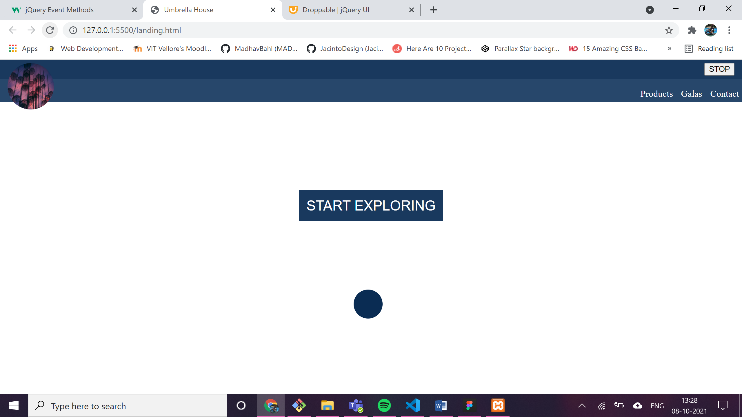**slidedown** and **slideup** is applied on the Heading “Welcome to umbrella house”

After few seconds (heading appears with animation effect “slow”)

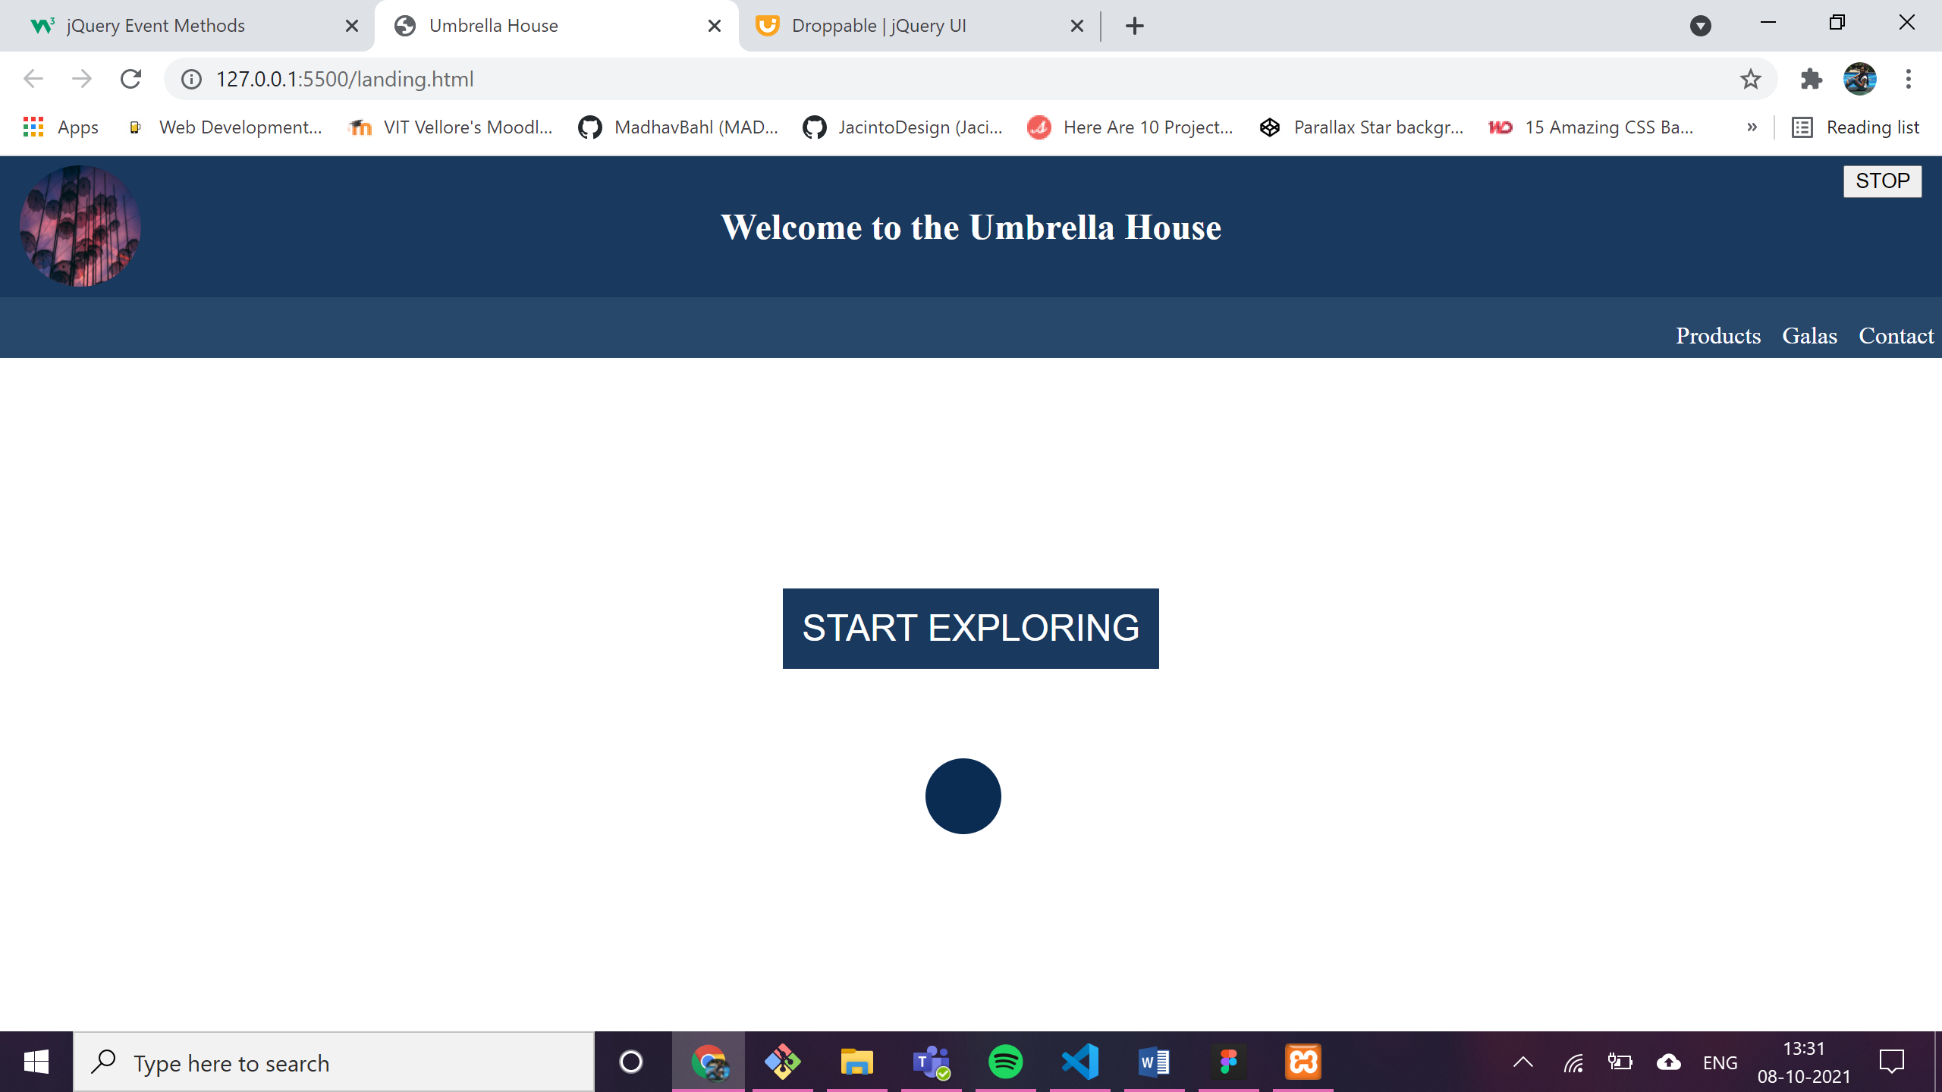

1. On clicking on start exploring: loading animation + start exploring button disappears. Effect can be stopped by clicking on the stop button present at the top right corner at any time. After the animation, the main content will be displayed using slidedown and an alert will be shown to welcome the user.

**(Hide, slidedown, animate, hide, stop, click)**

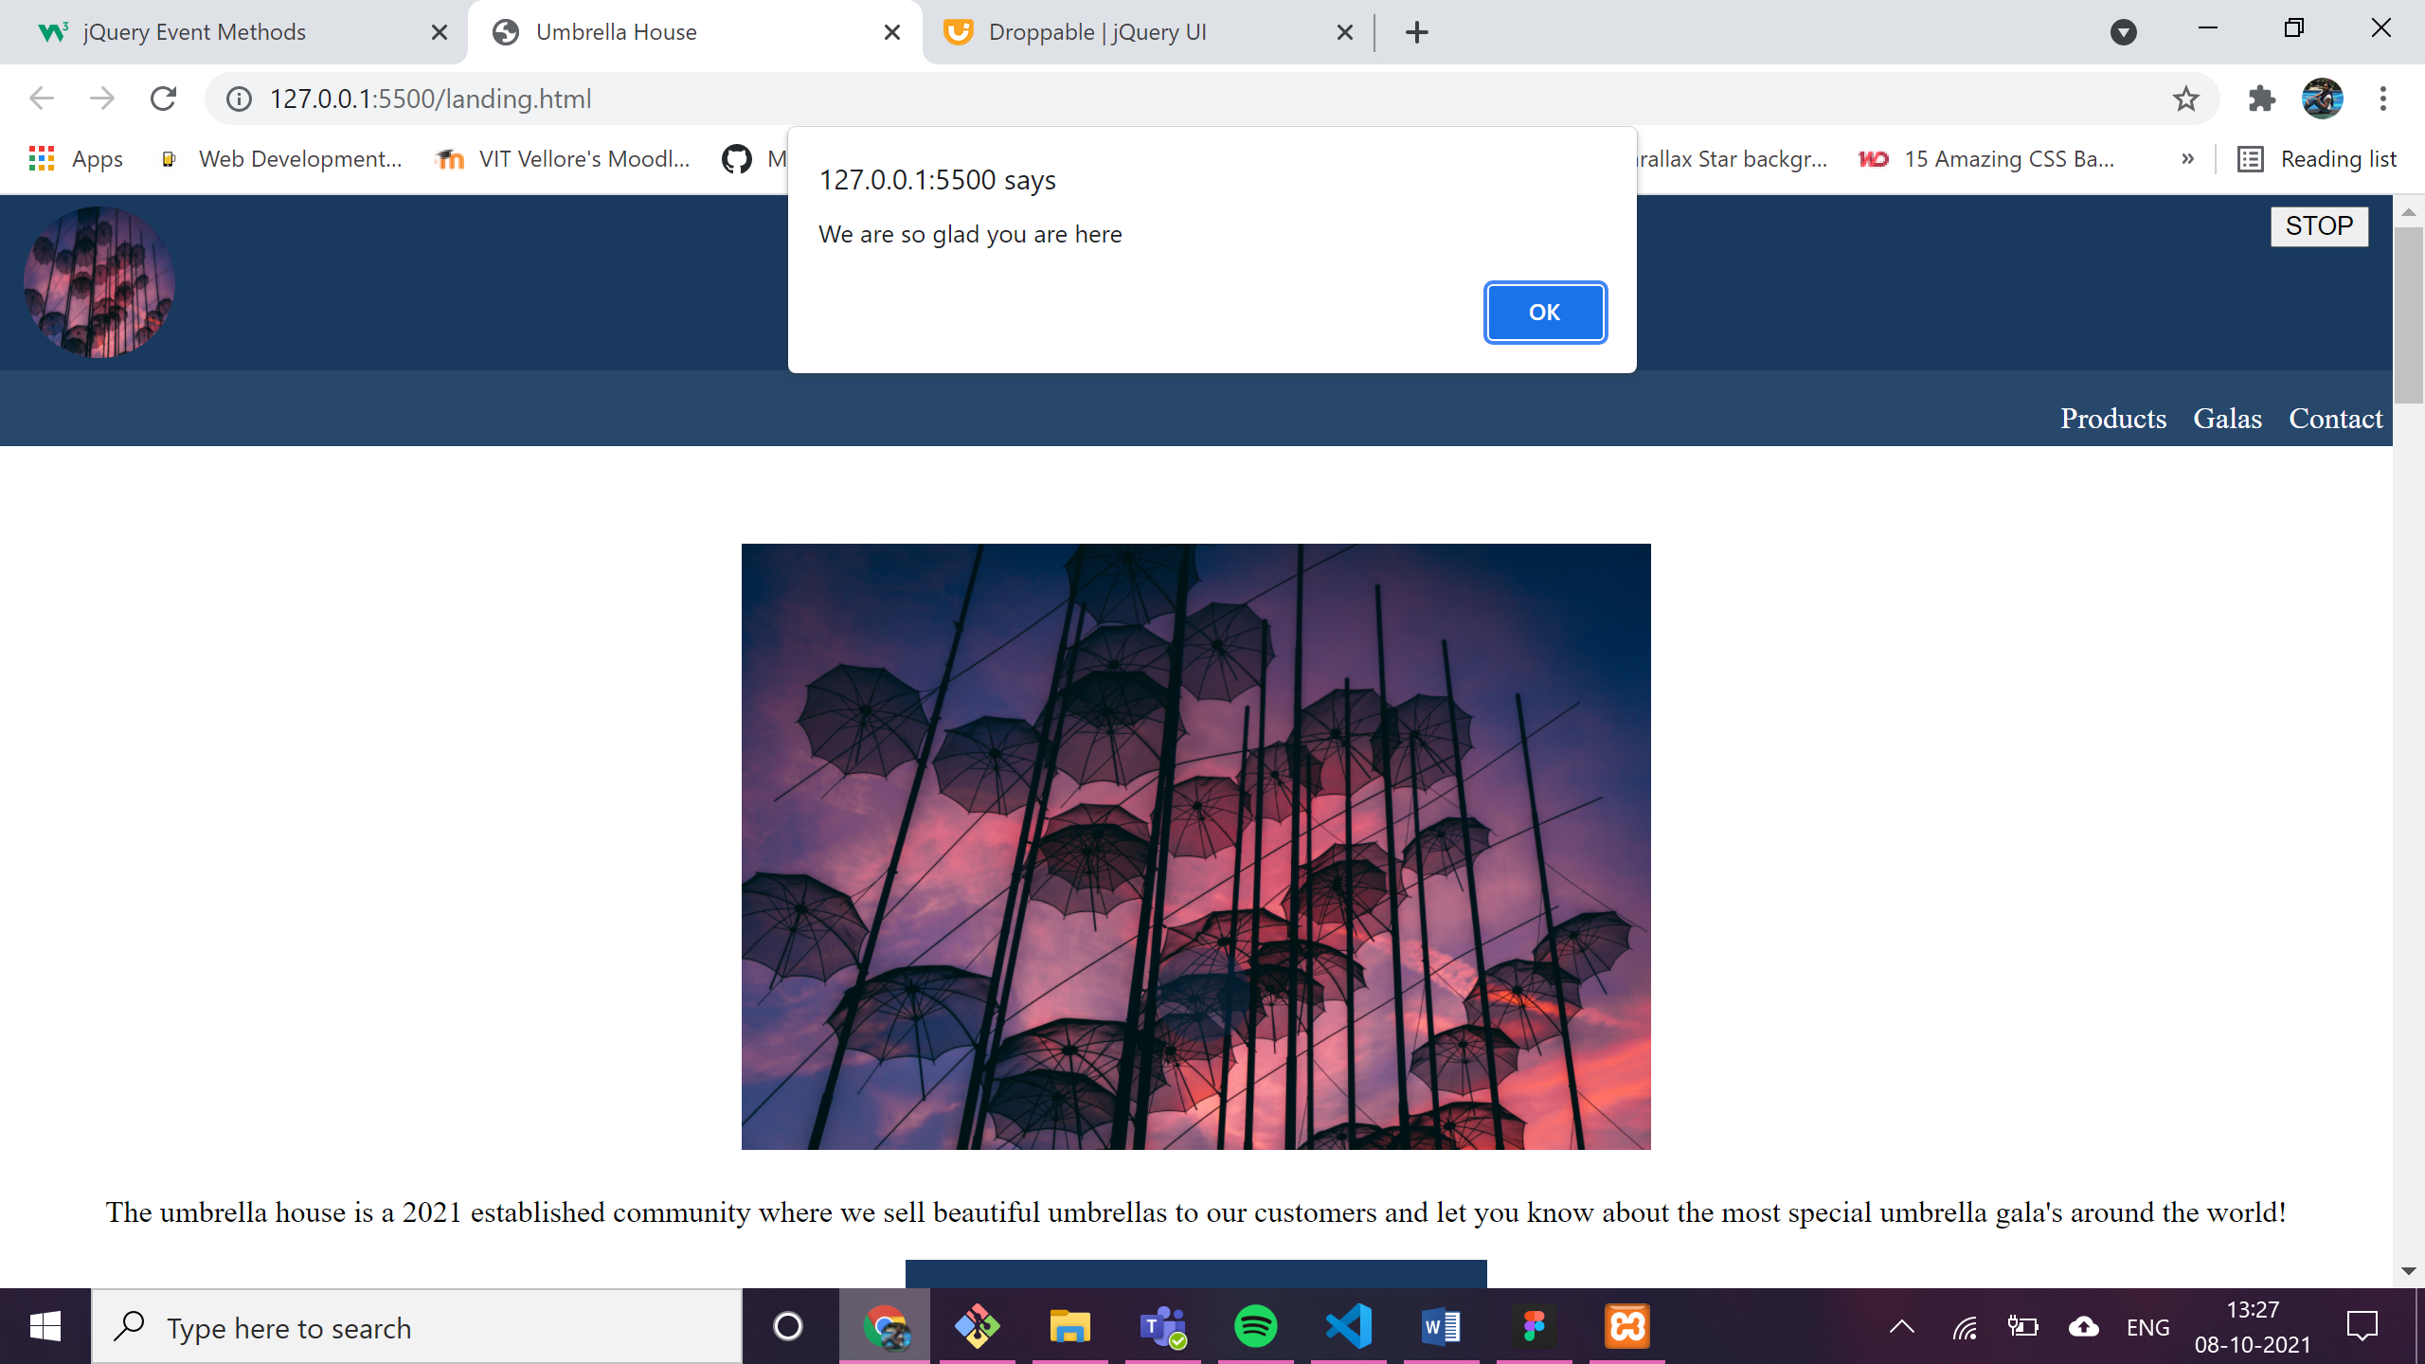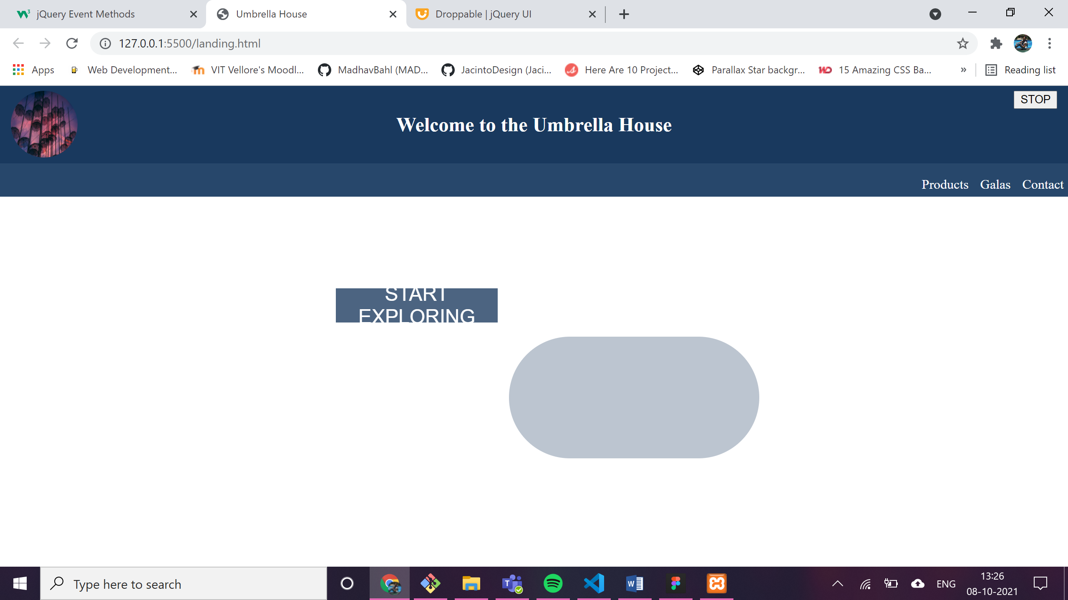

1. 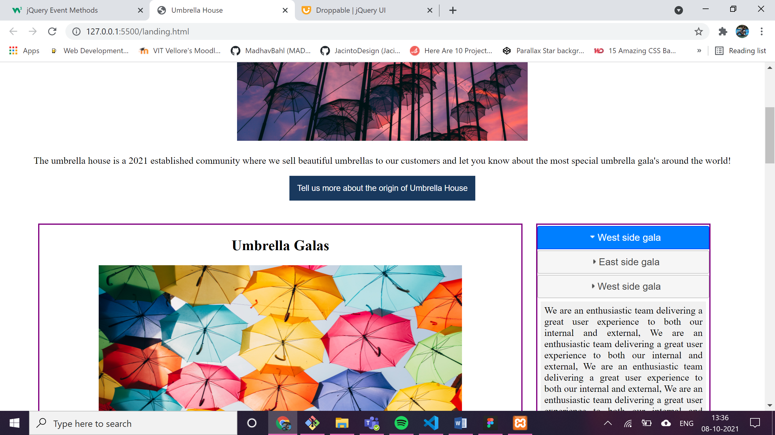Toggle show

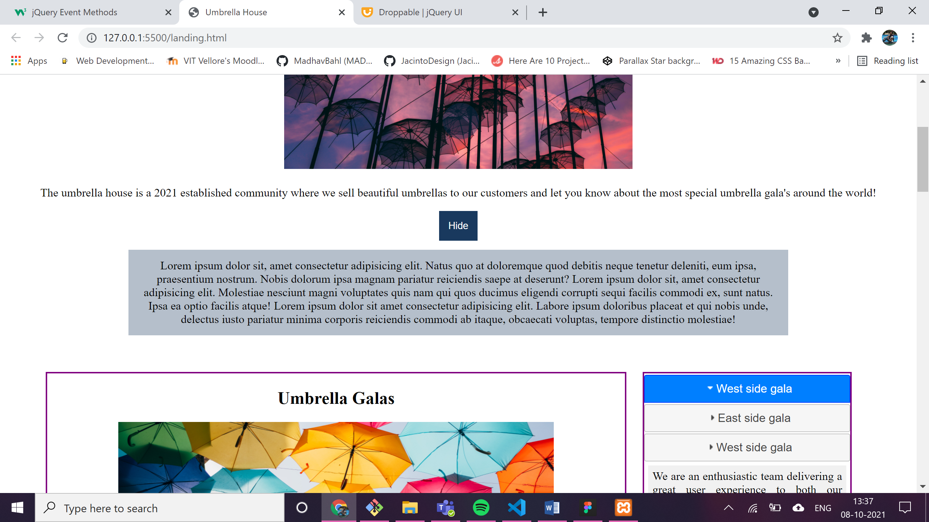

1. **mouse events**
   1. 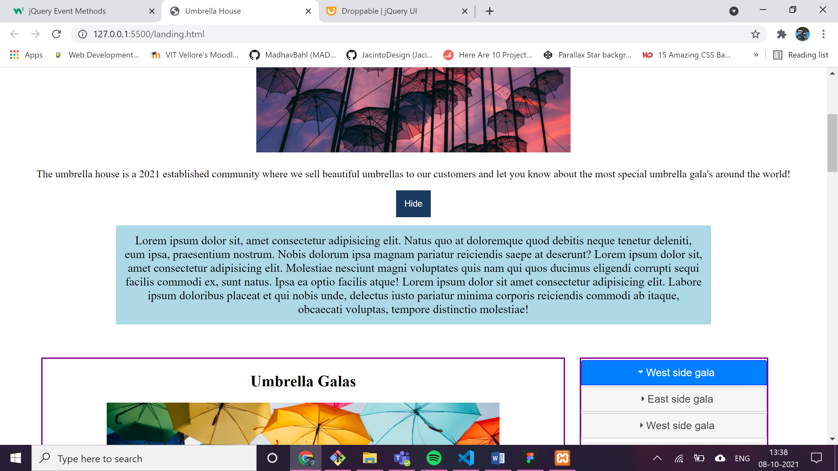On **mouseenter** the grey box as seen in the above image will turn into a grey image with increased font-size.
   2. On **mouseleave**, the color is reverted back to grey and small font size

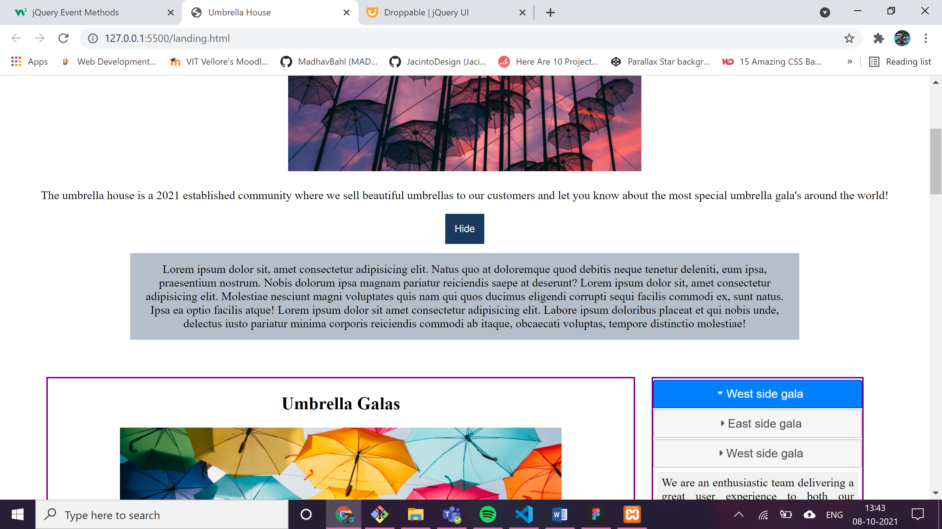

* 1. On **click**ing on the div, the background changes to yellow.

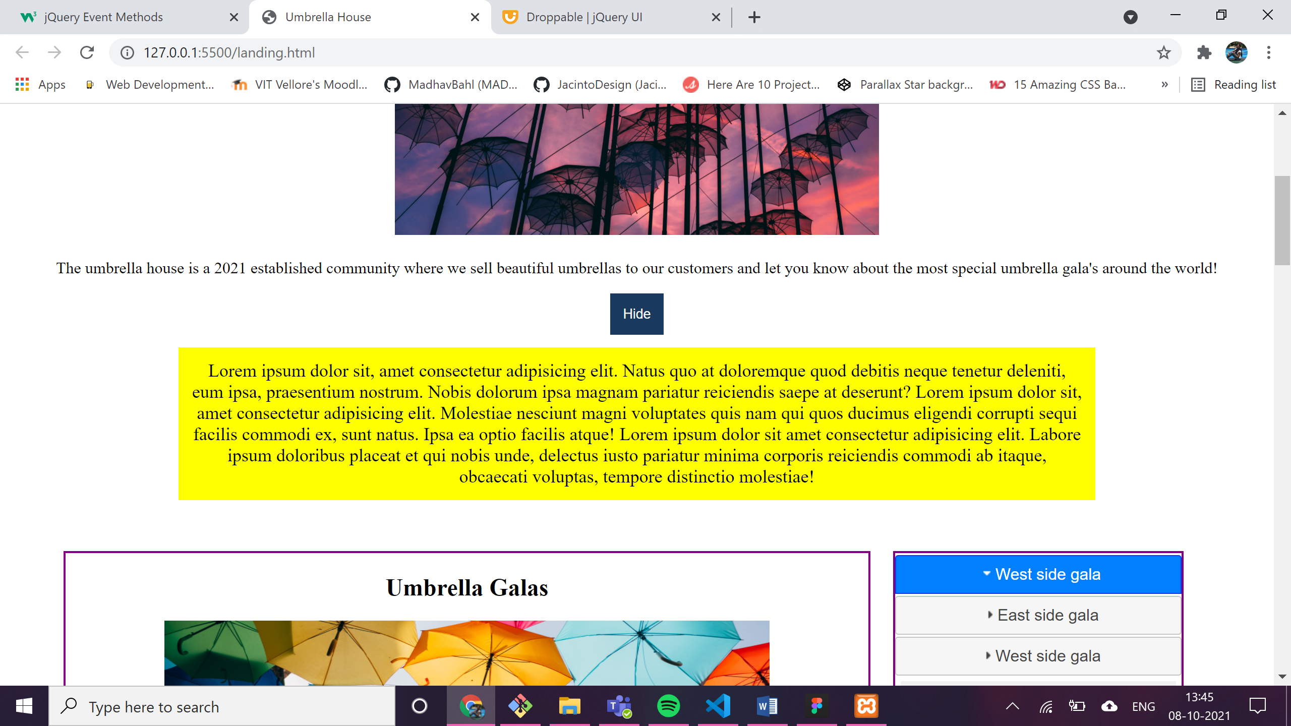

1. Jquery UI widget – accordion

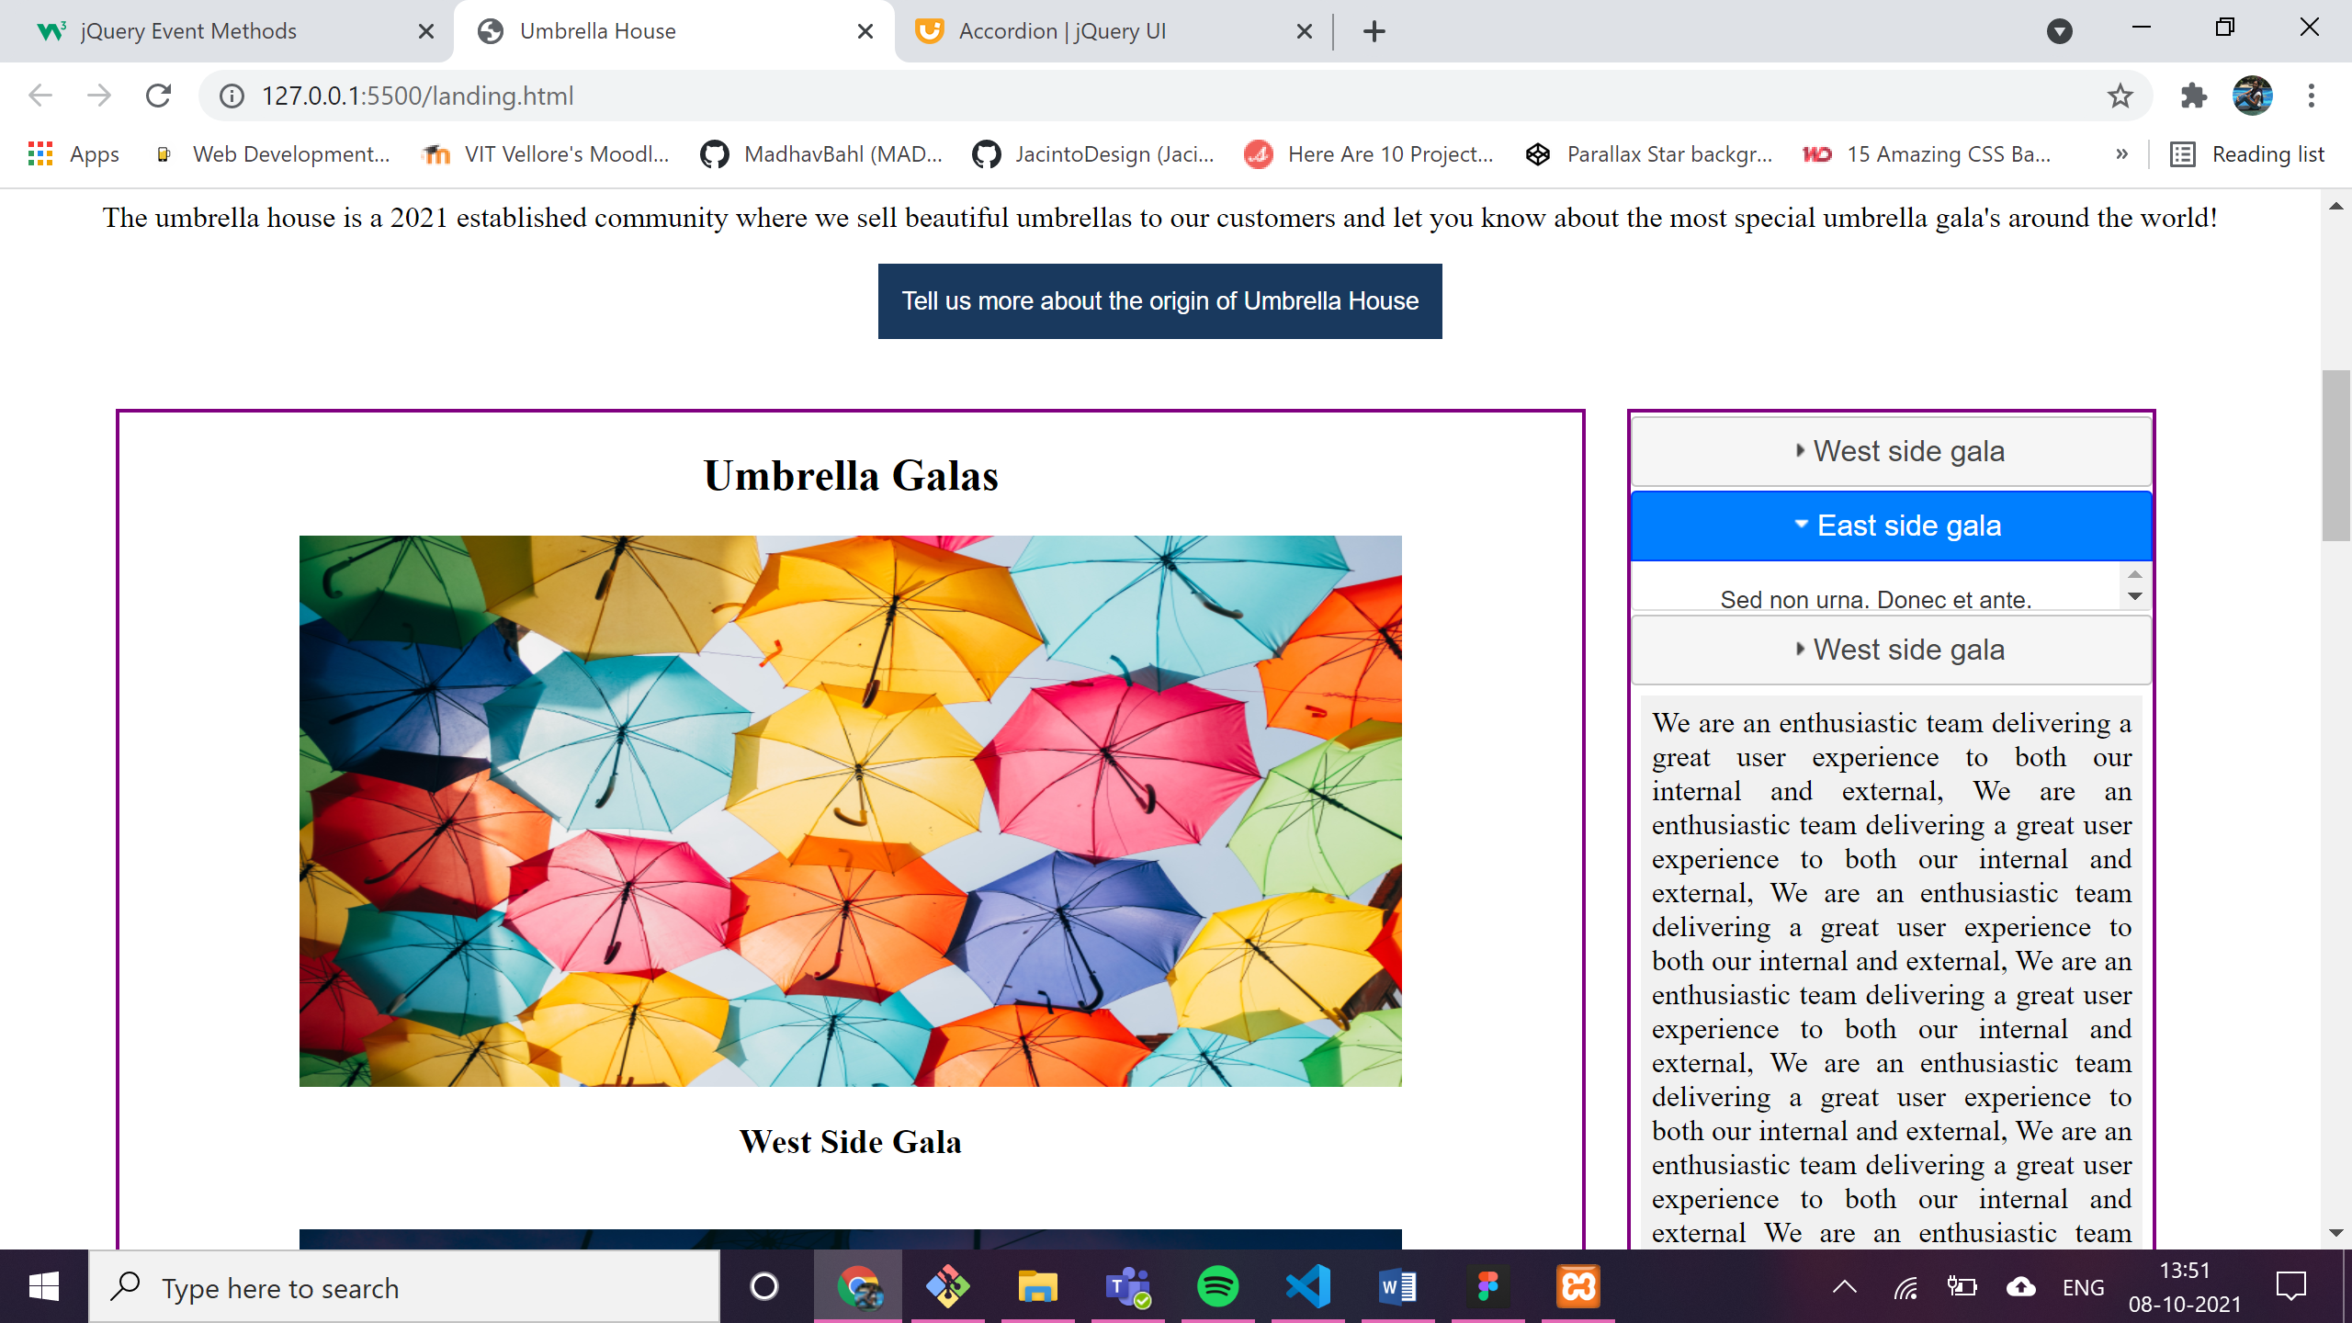

1. **FadeIn** animations: on clicking on the show products button -> products are displayed one after the other as a animation

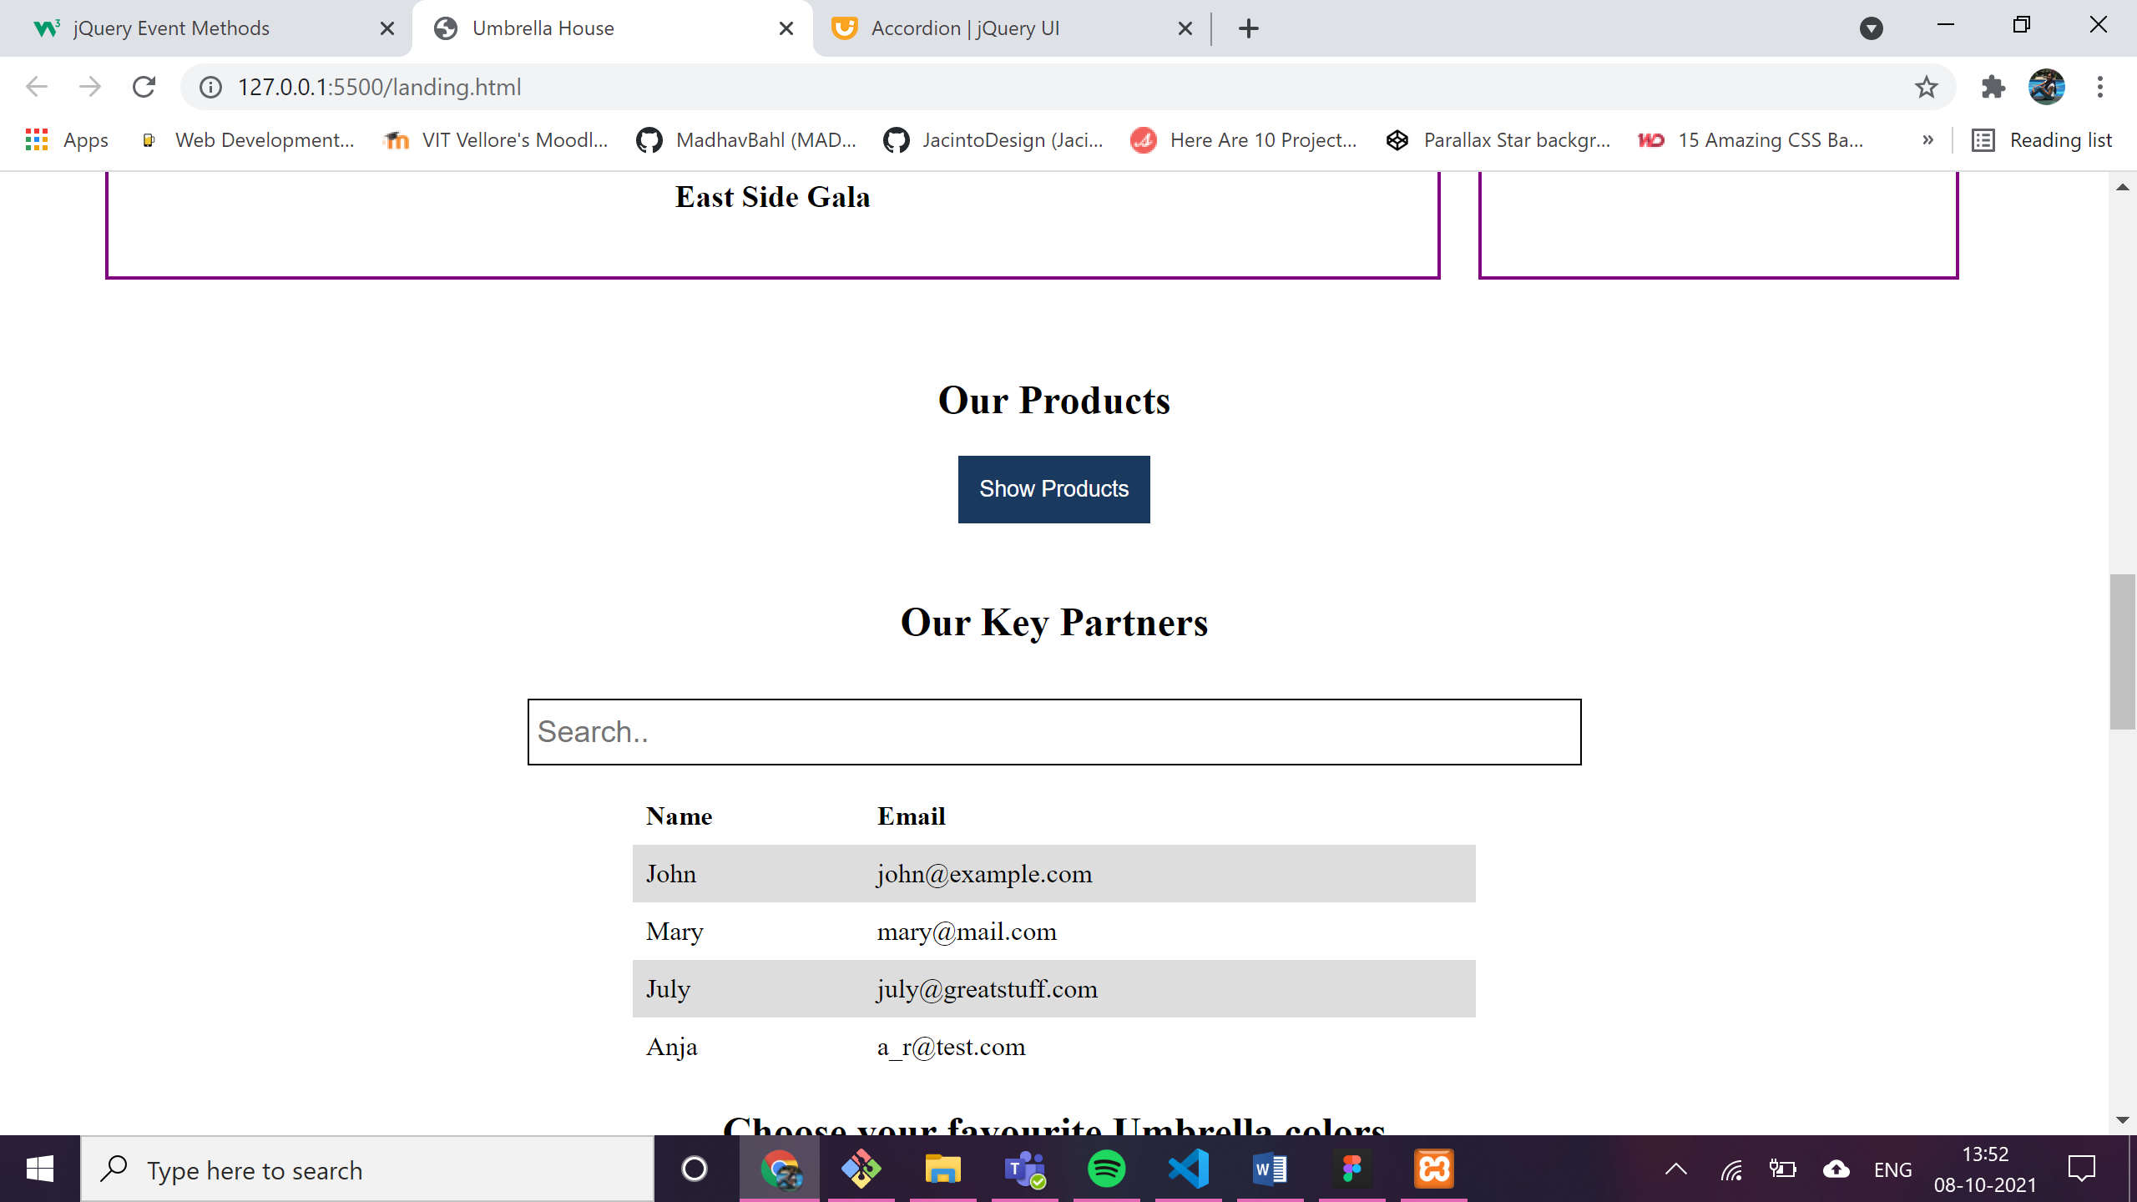

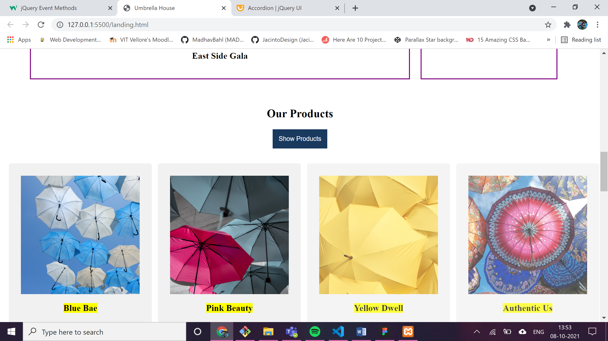

1. On **hover** on any product the size of that product card increases.

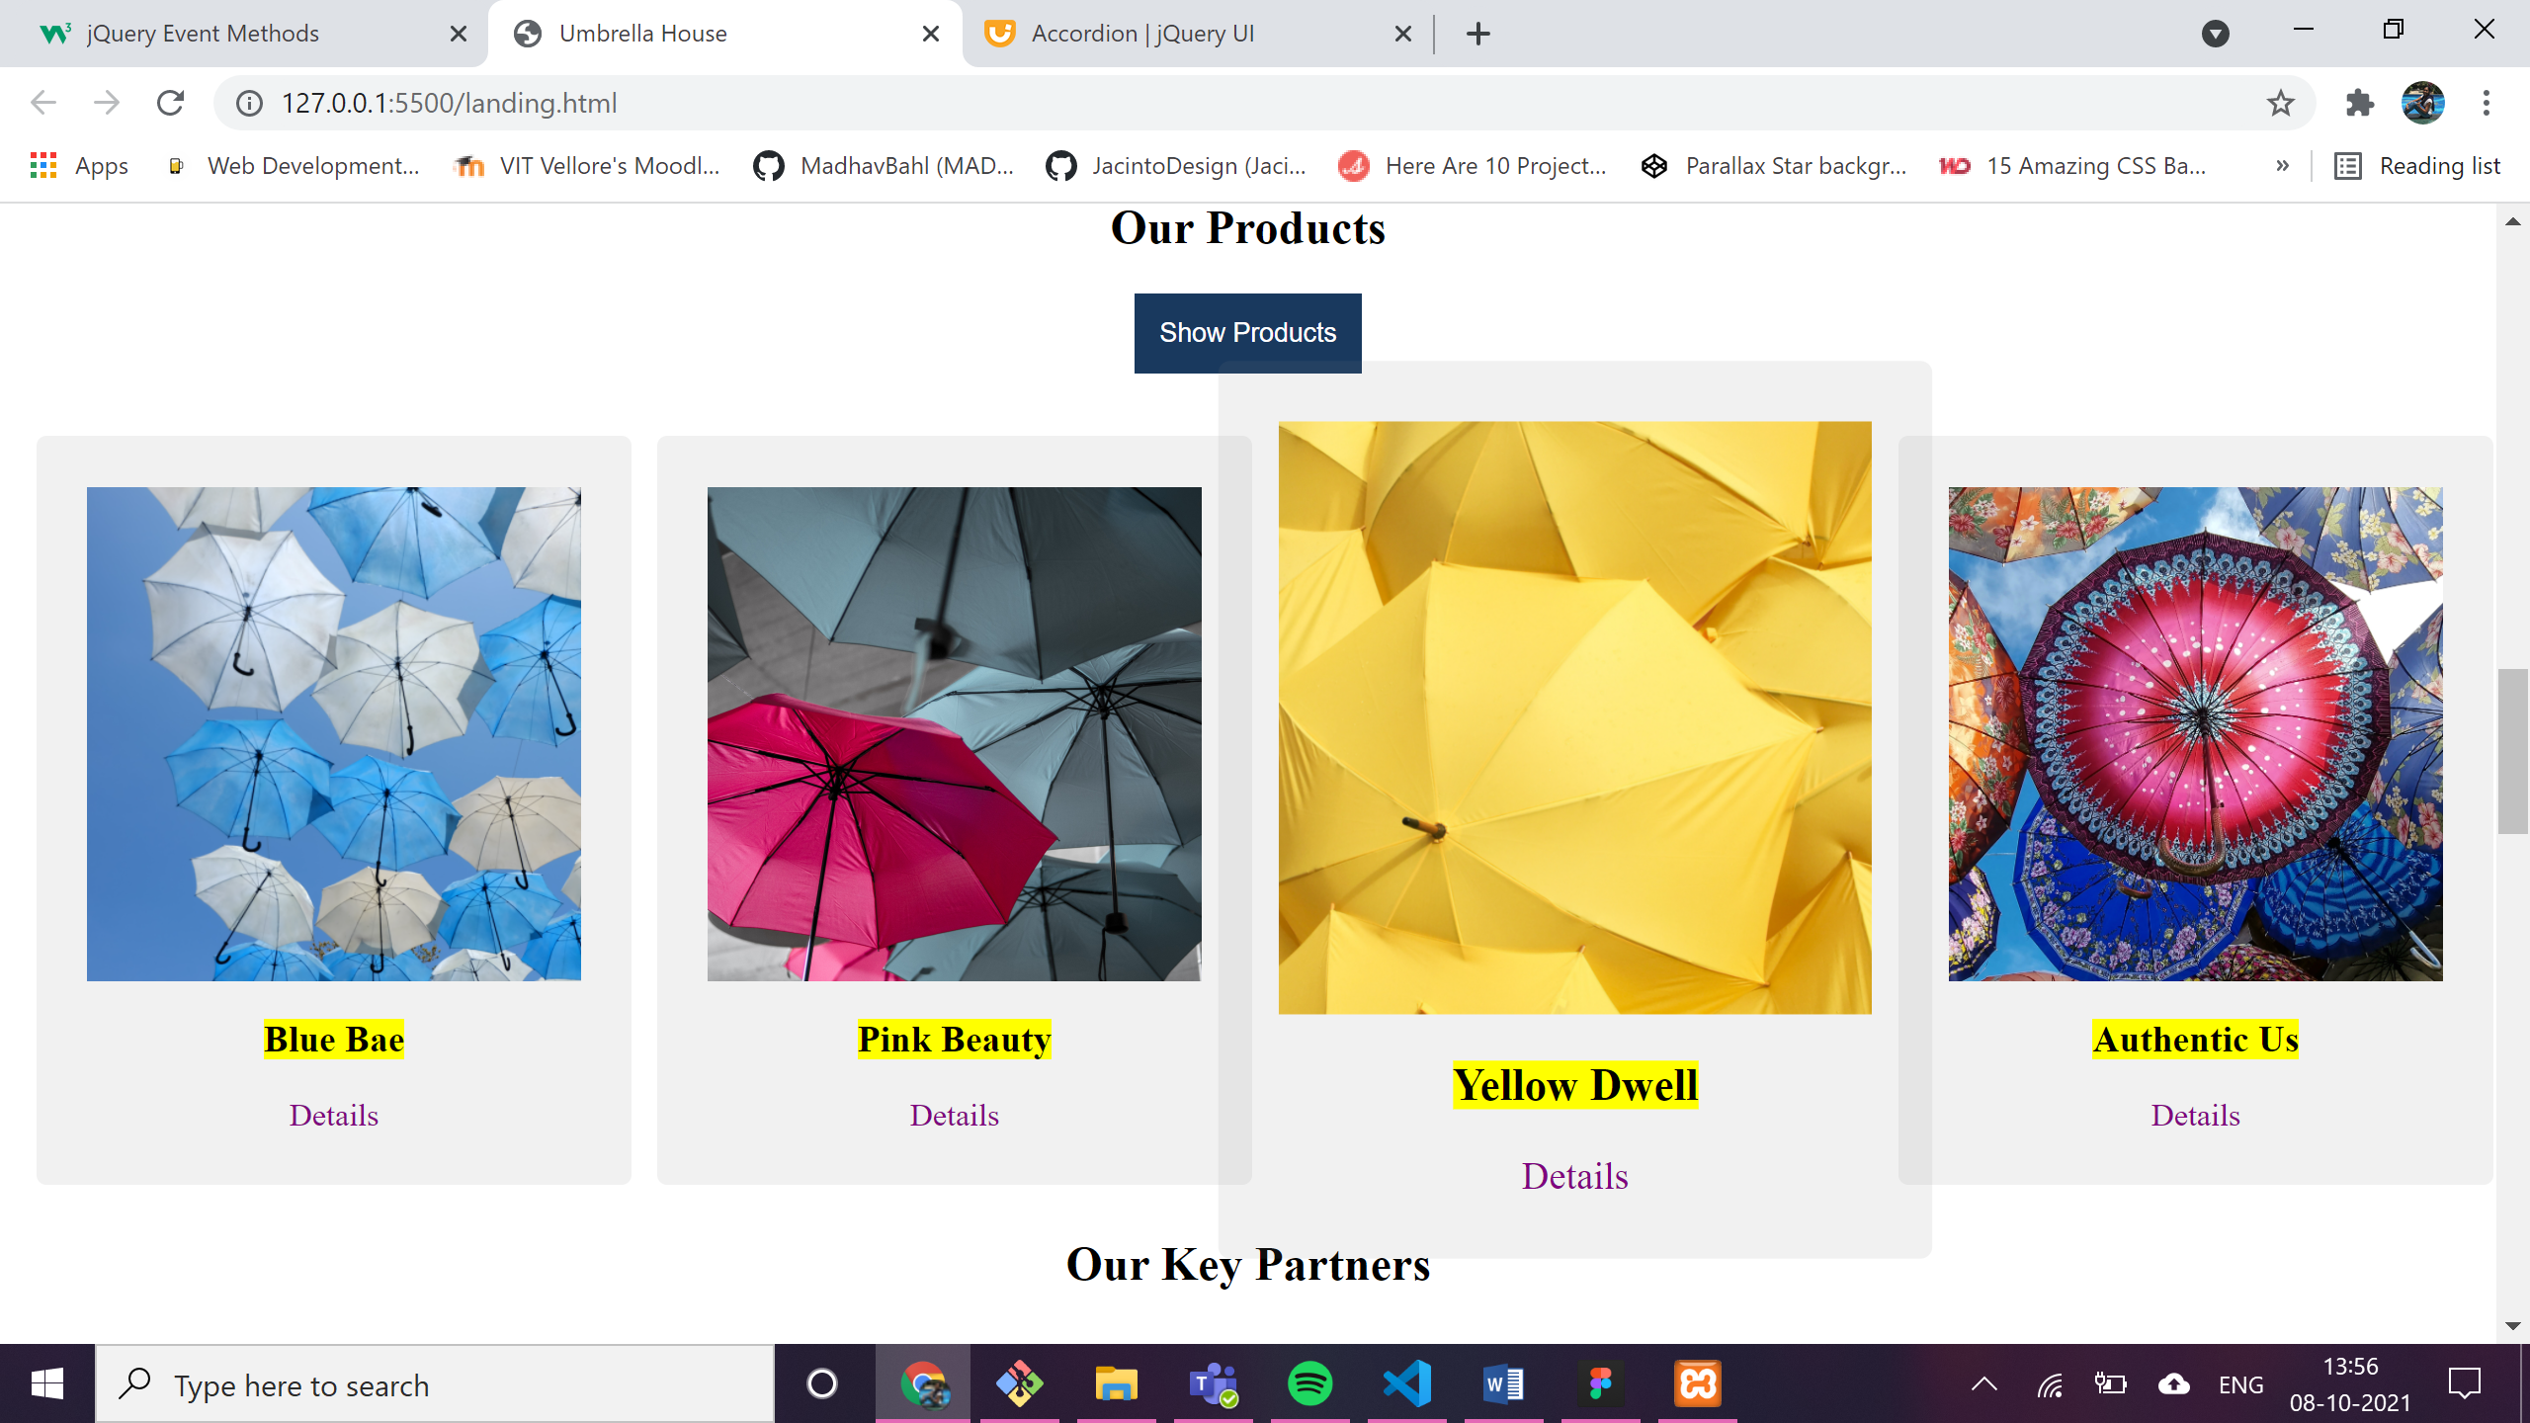

1. Filter method applied on the html table:

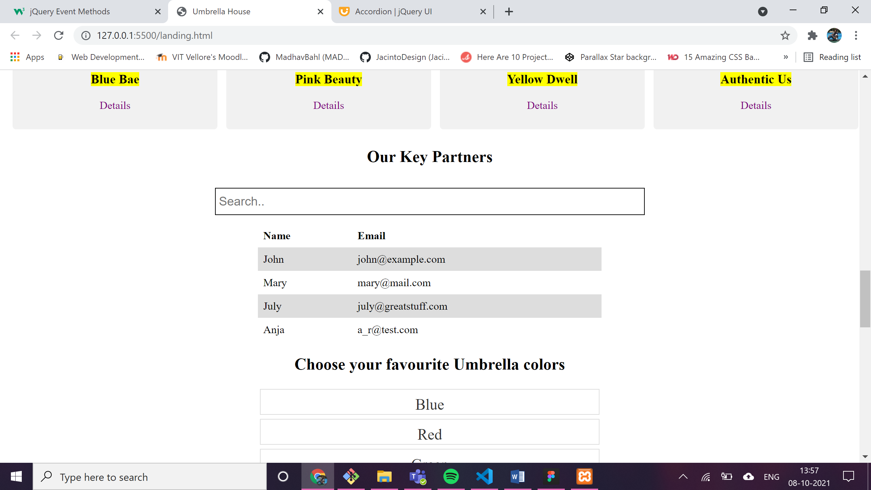

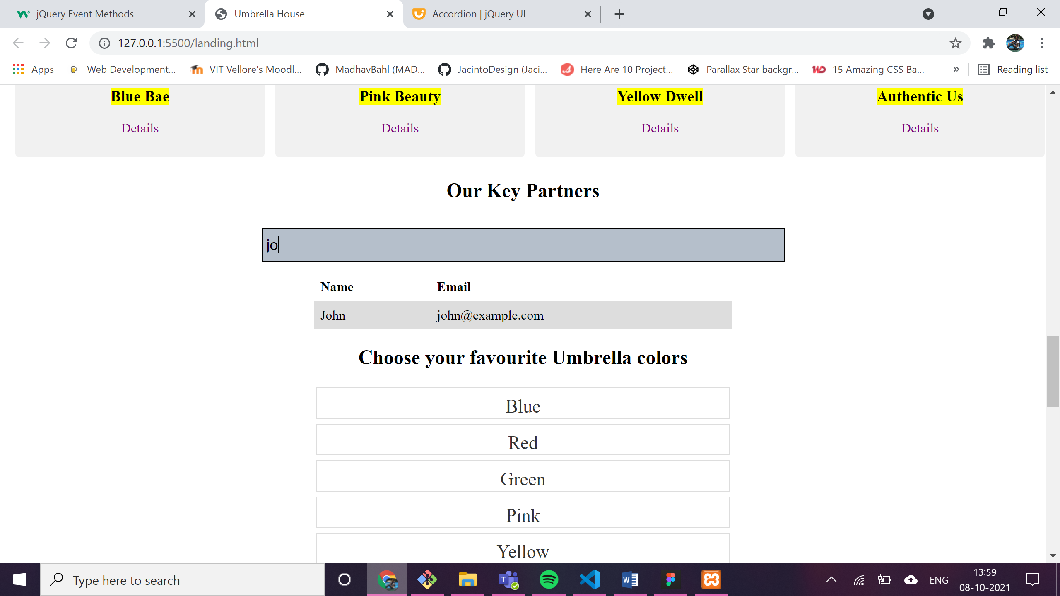

1. **Selectable** jquery ui interaction :on corresponding select the color will be highlighted

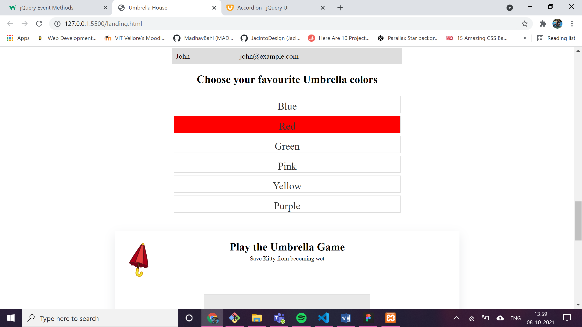

1. **Draggable** and **droppable** widgets

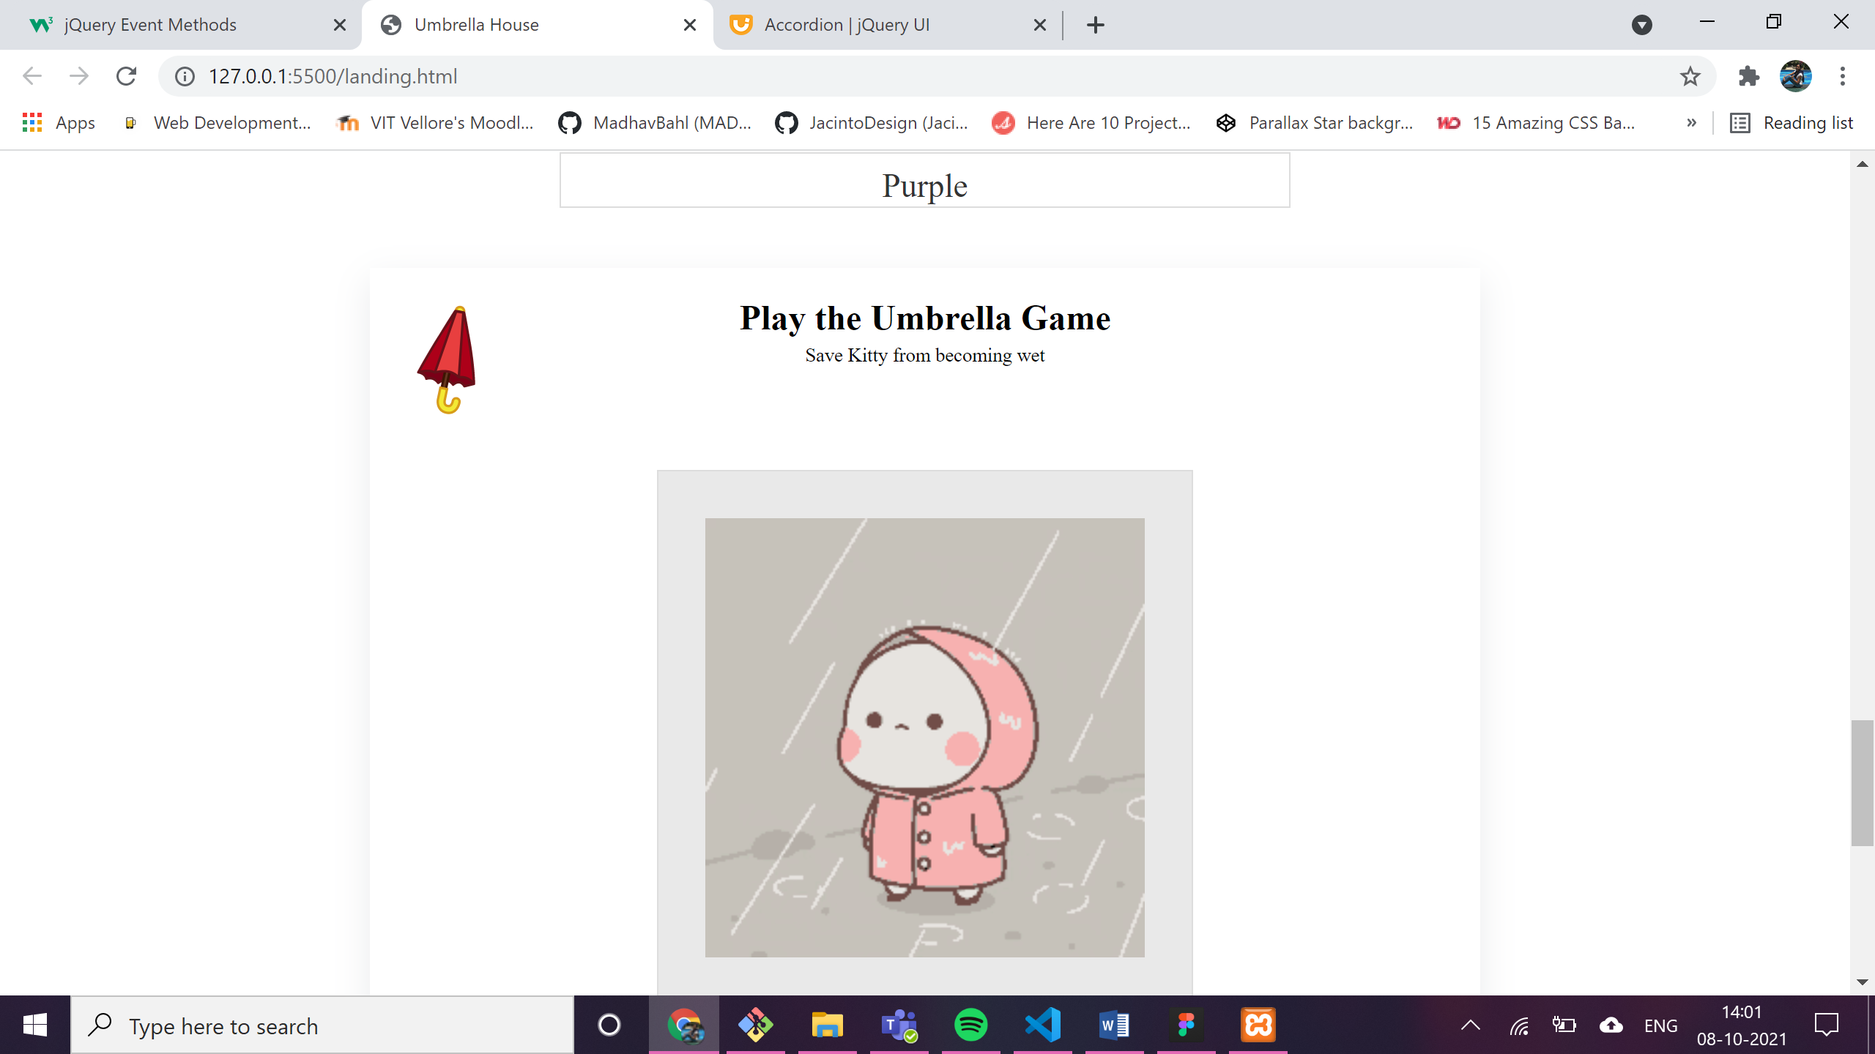

* on dropping the umbrella at the right place the box background will change and the font-size of “thank you” is increased from 3rem to 4rem with animation.

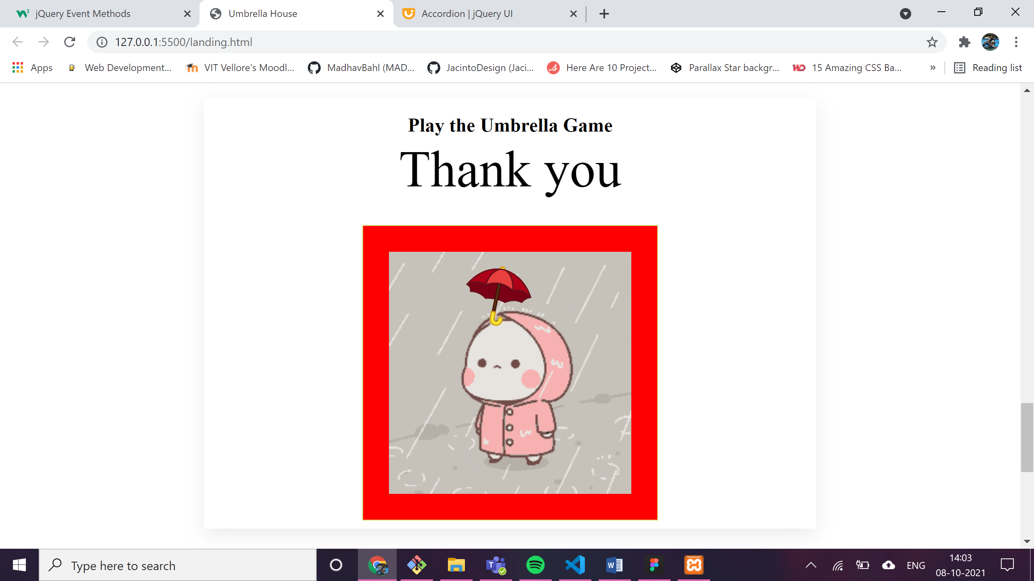

1. on single **click** on the section: color changes to light blue

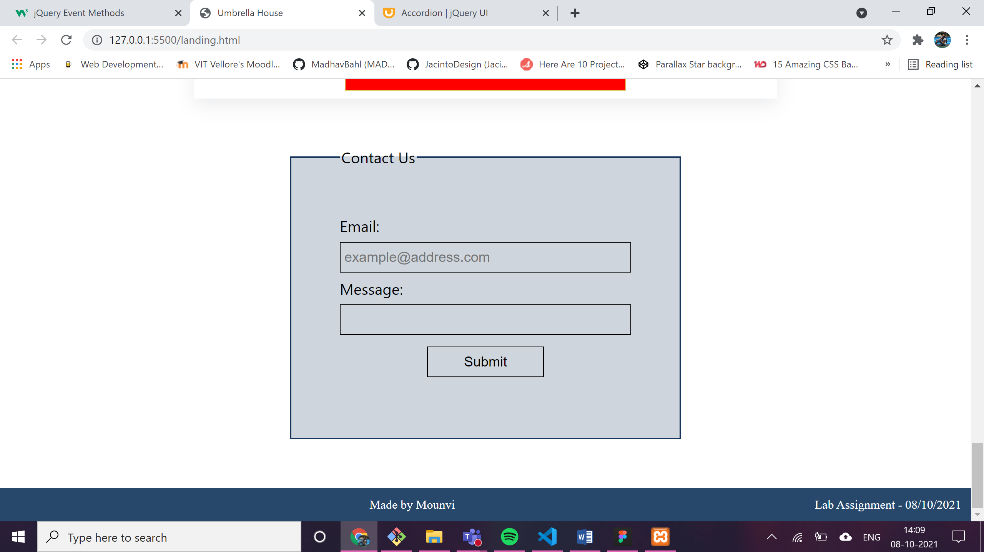

1. on **dblclick:** the background color changes to darker blue.

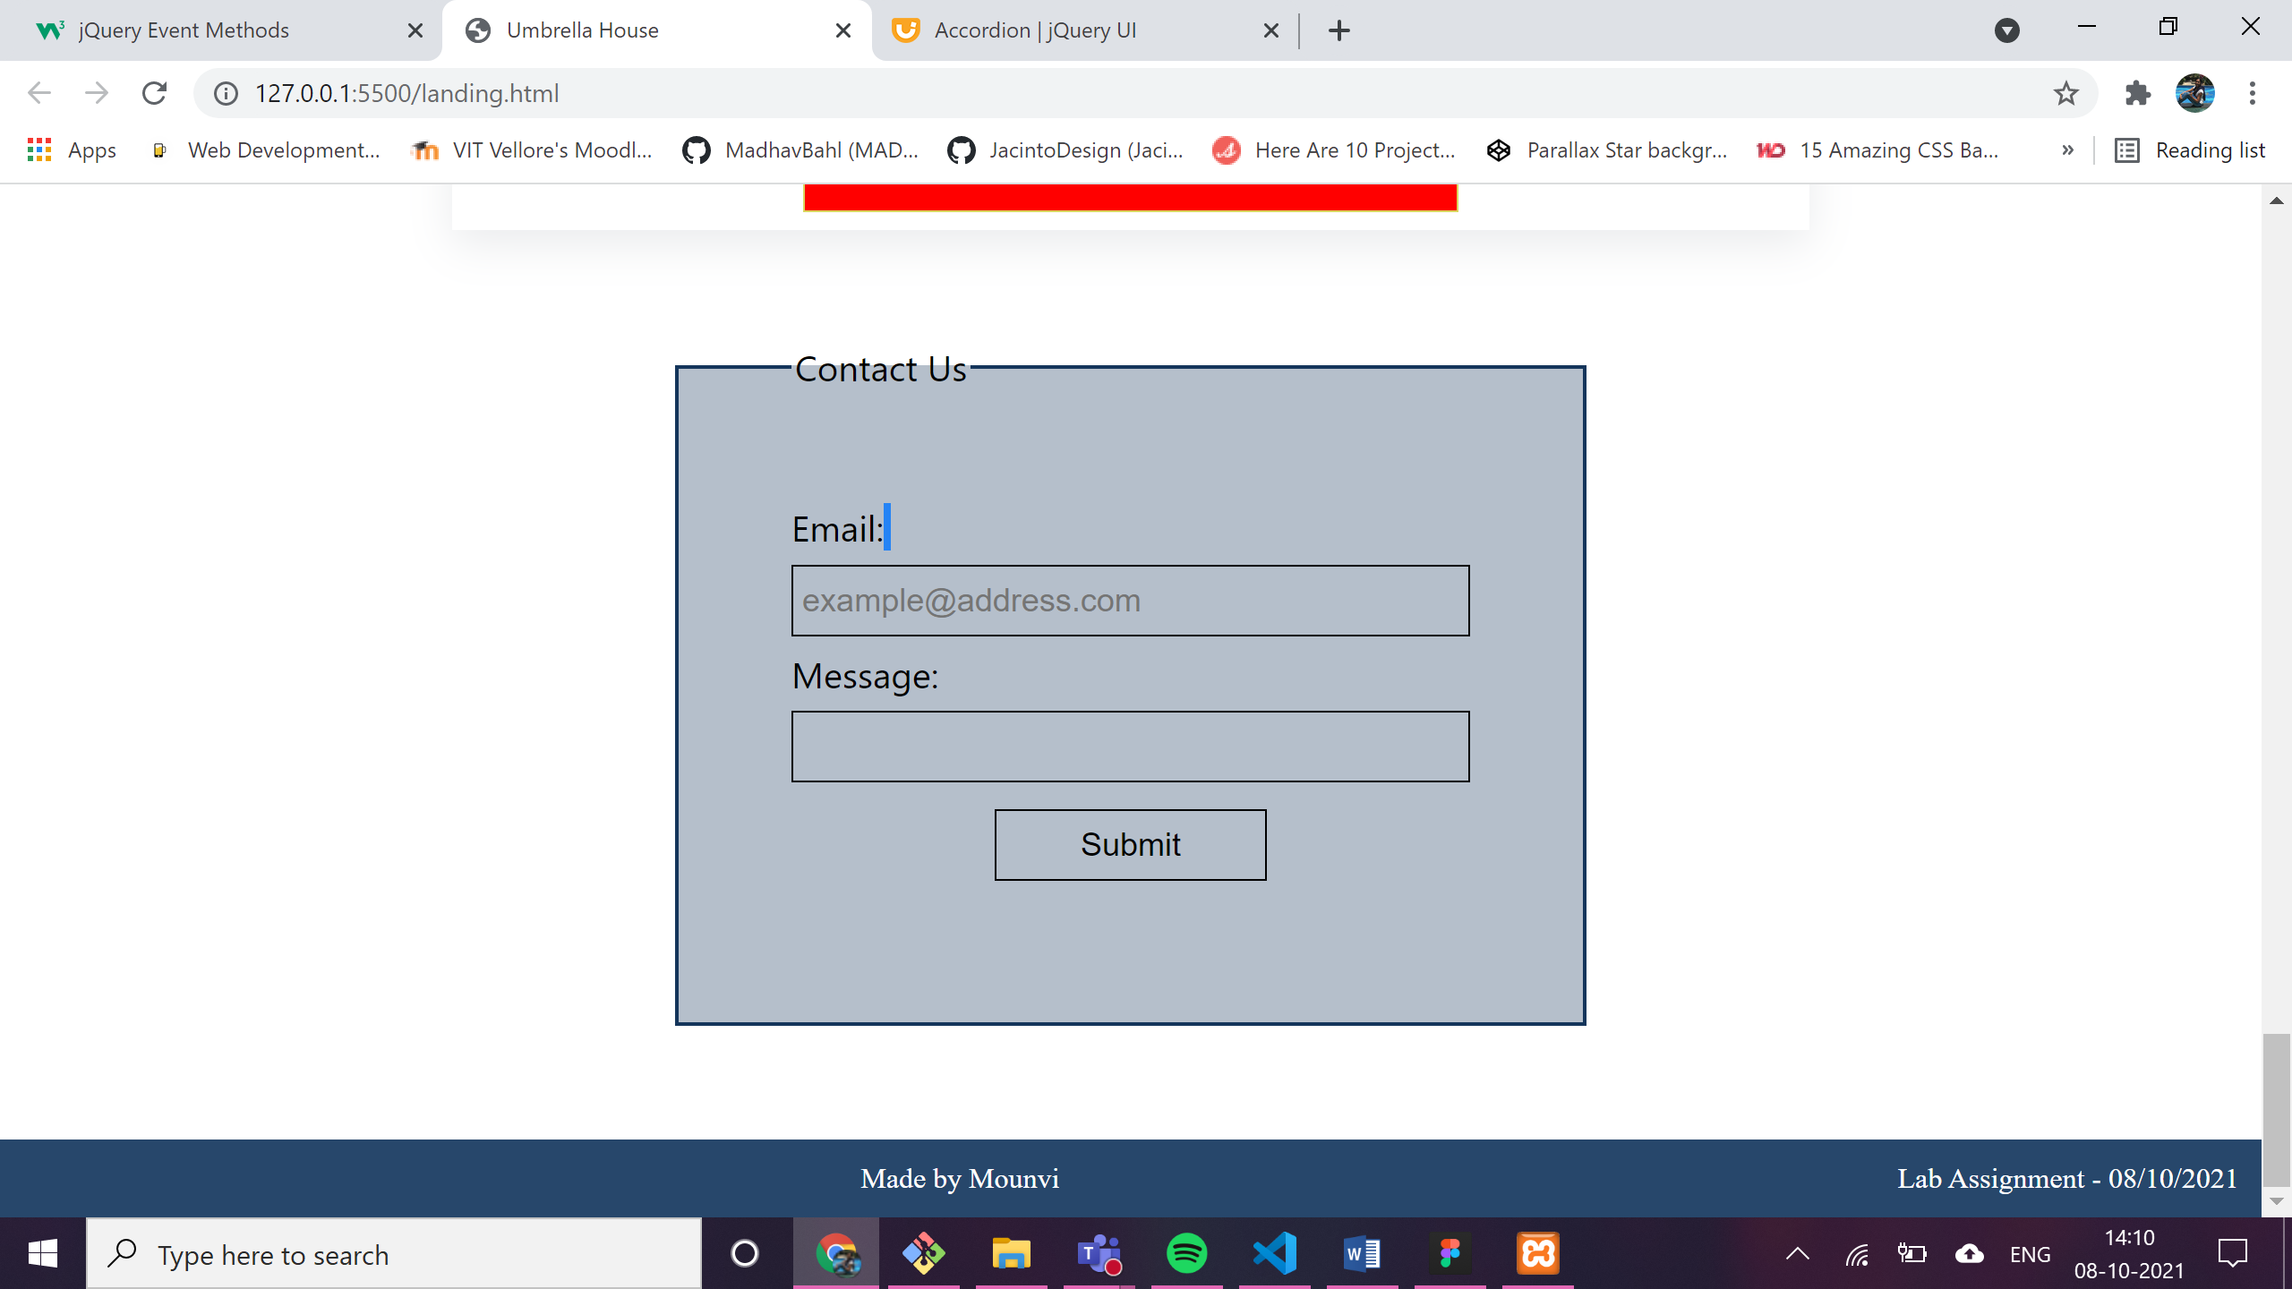

1. on **focus** and **blur** events:

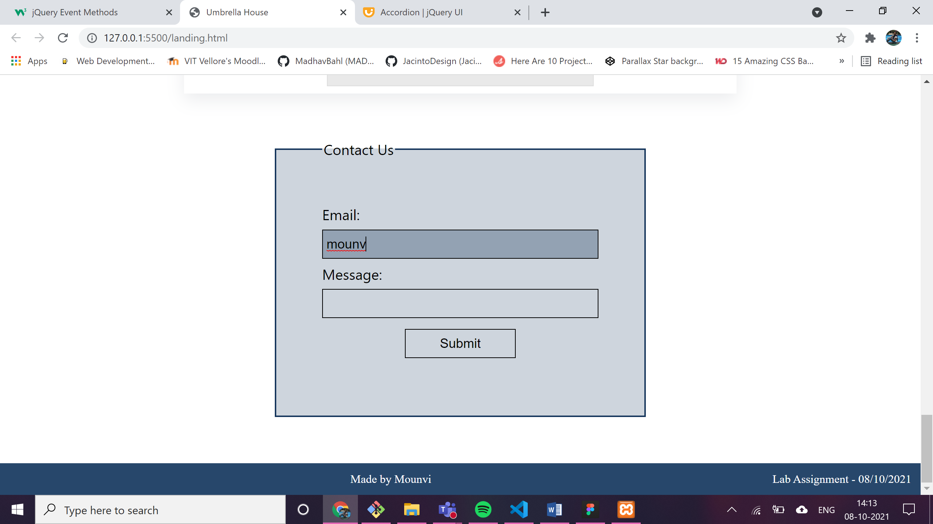

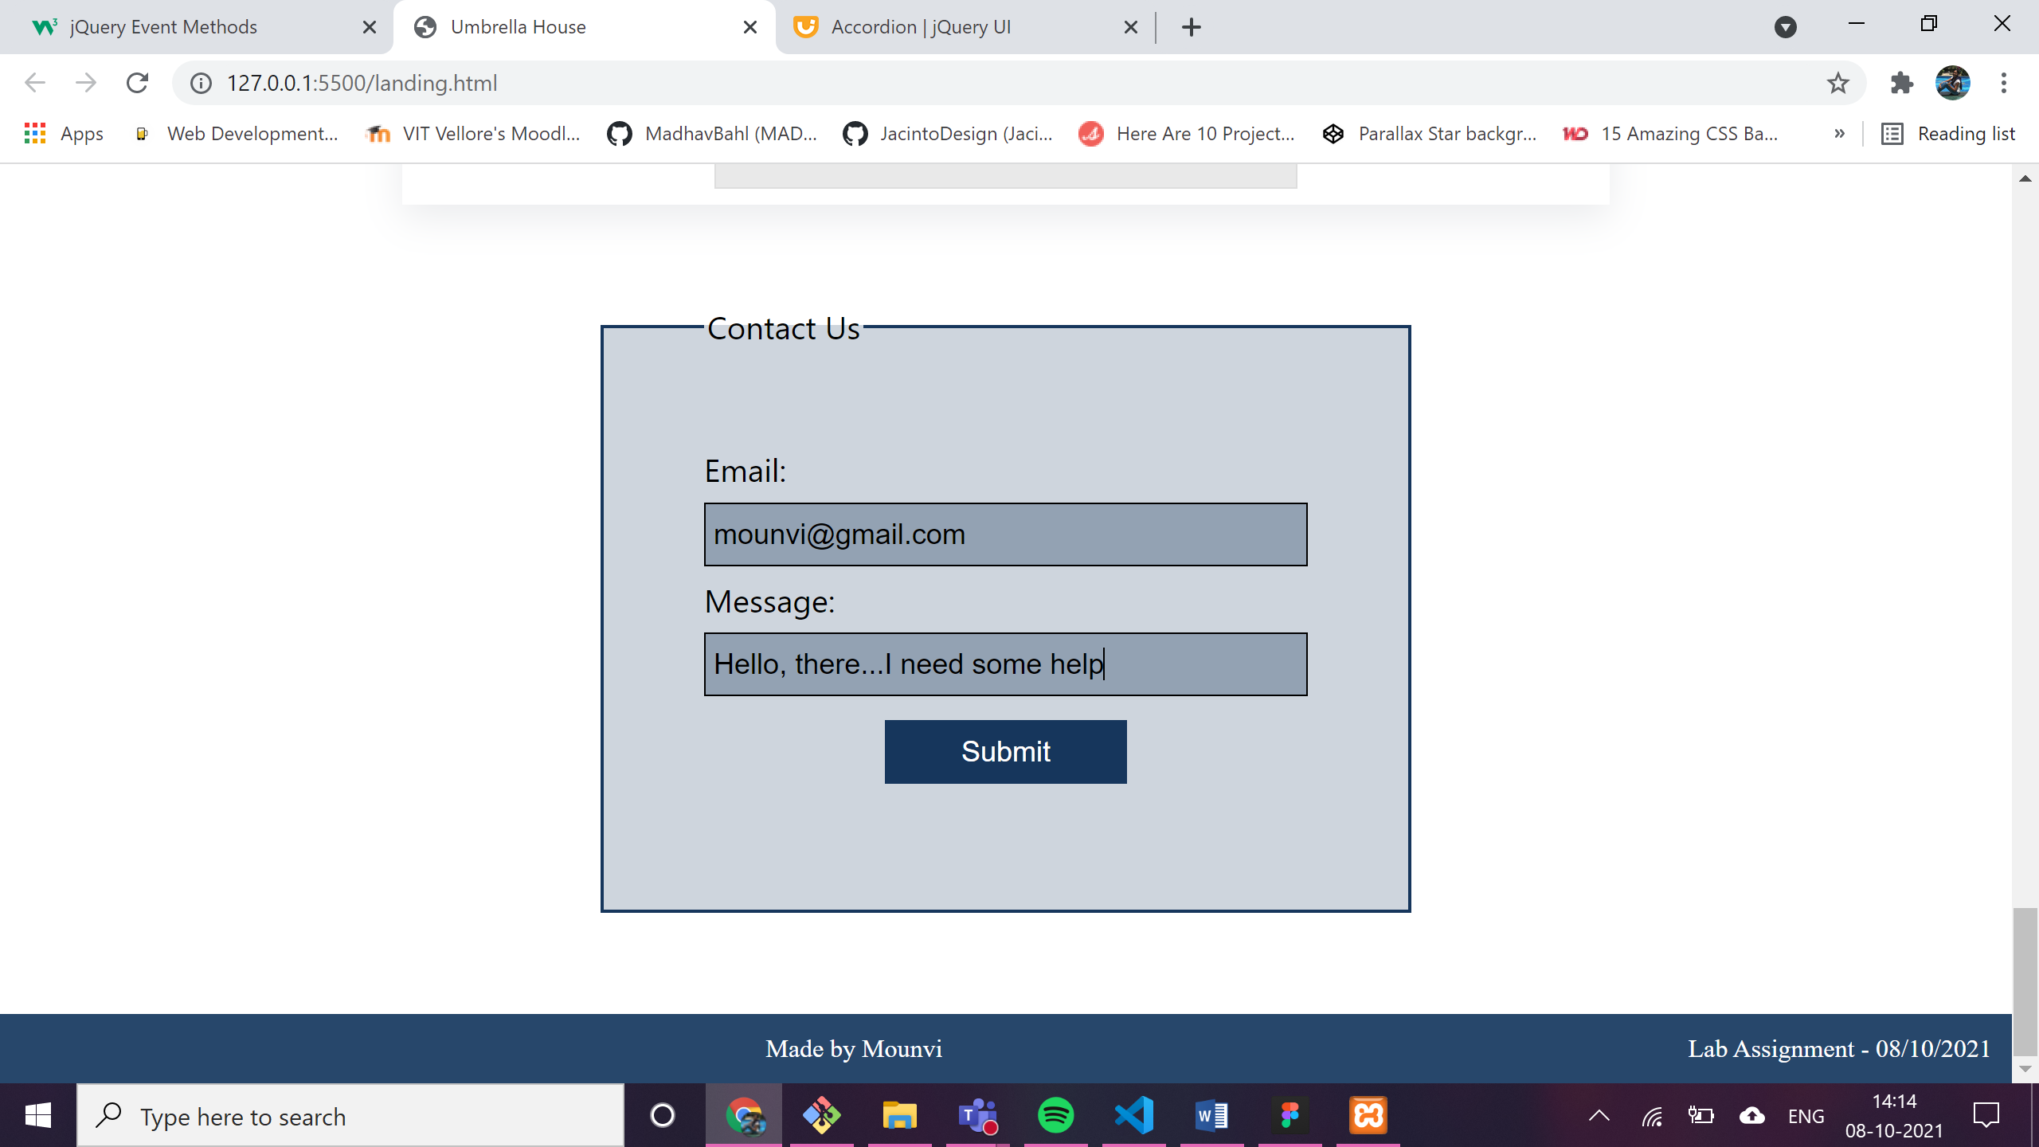

on **submit:**

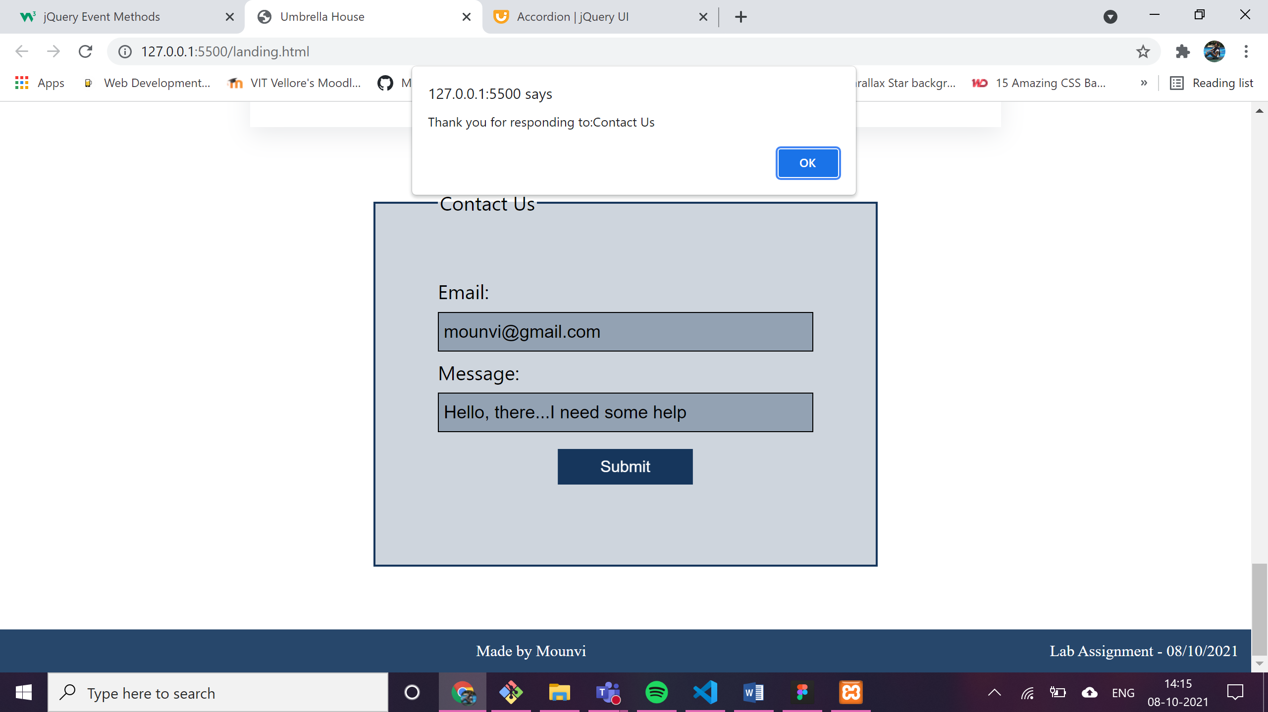

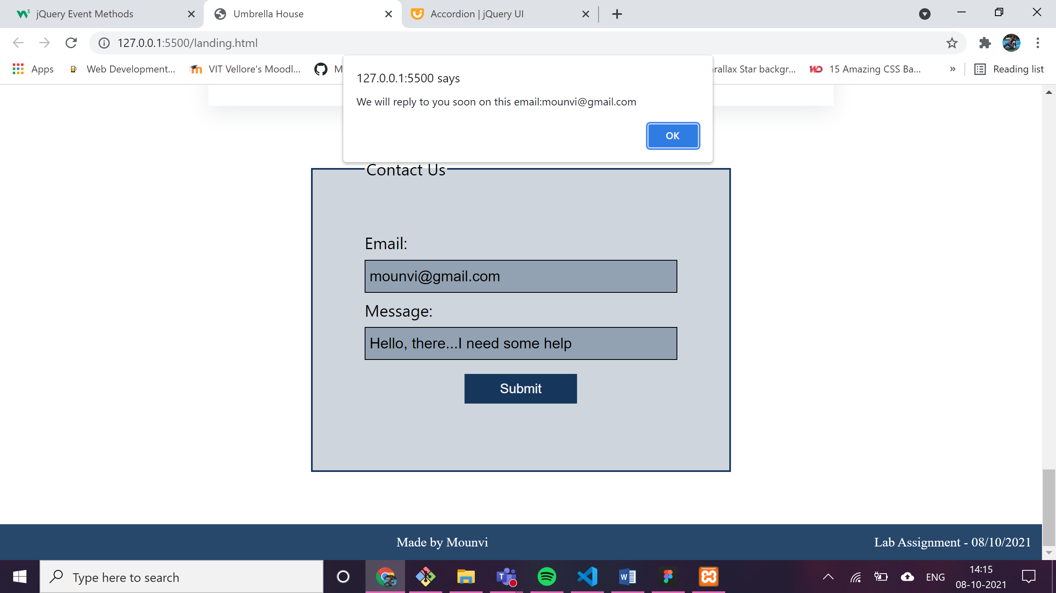

After submitting: the legend changes and the submit button is **disabled** and success image is displayed at the bottom using **“attr”**

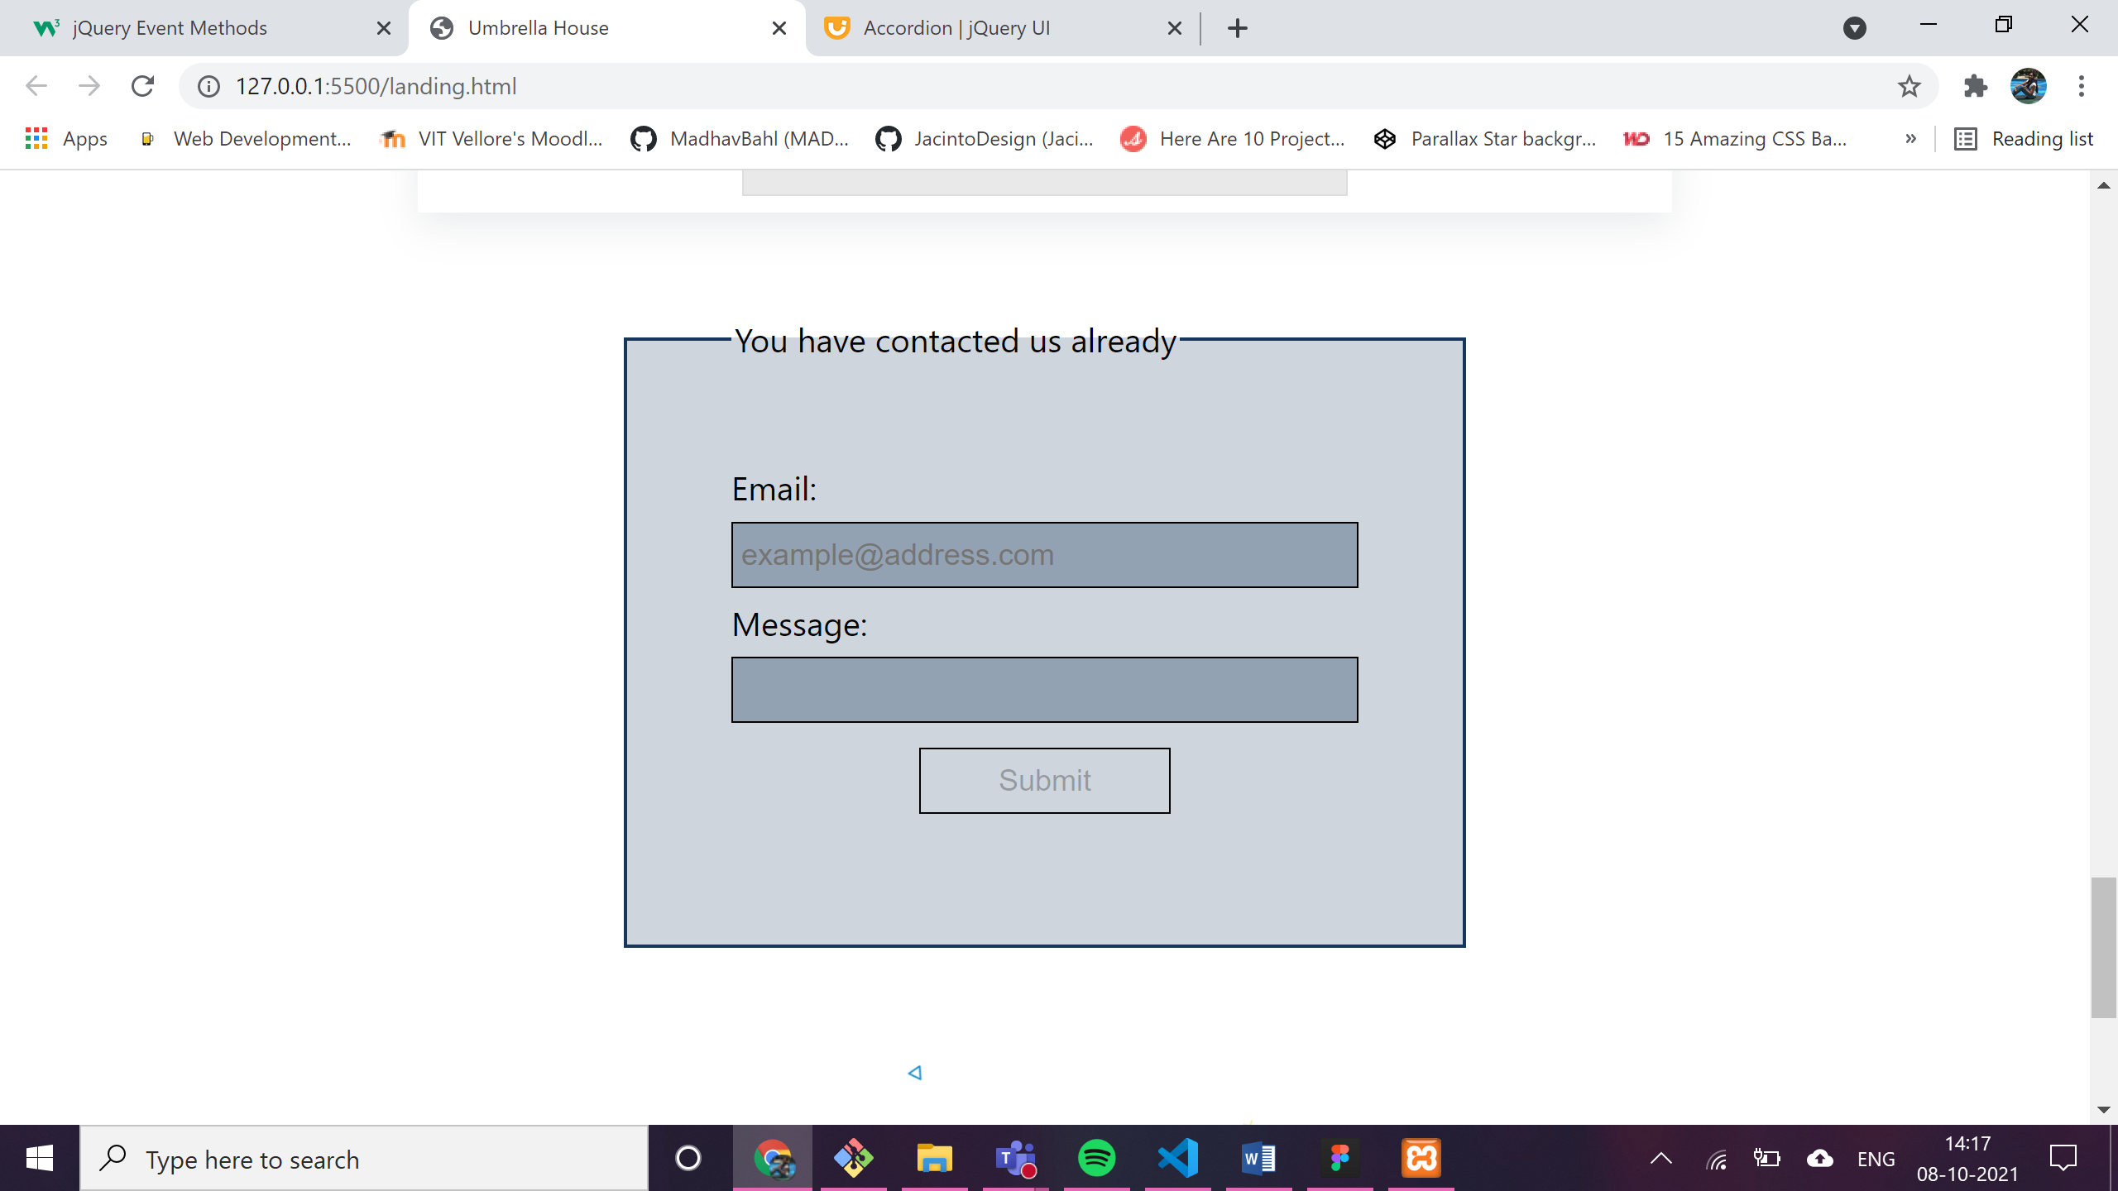

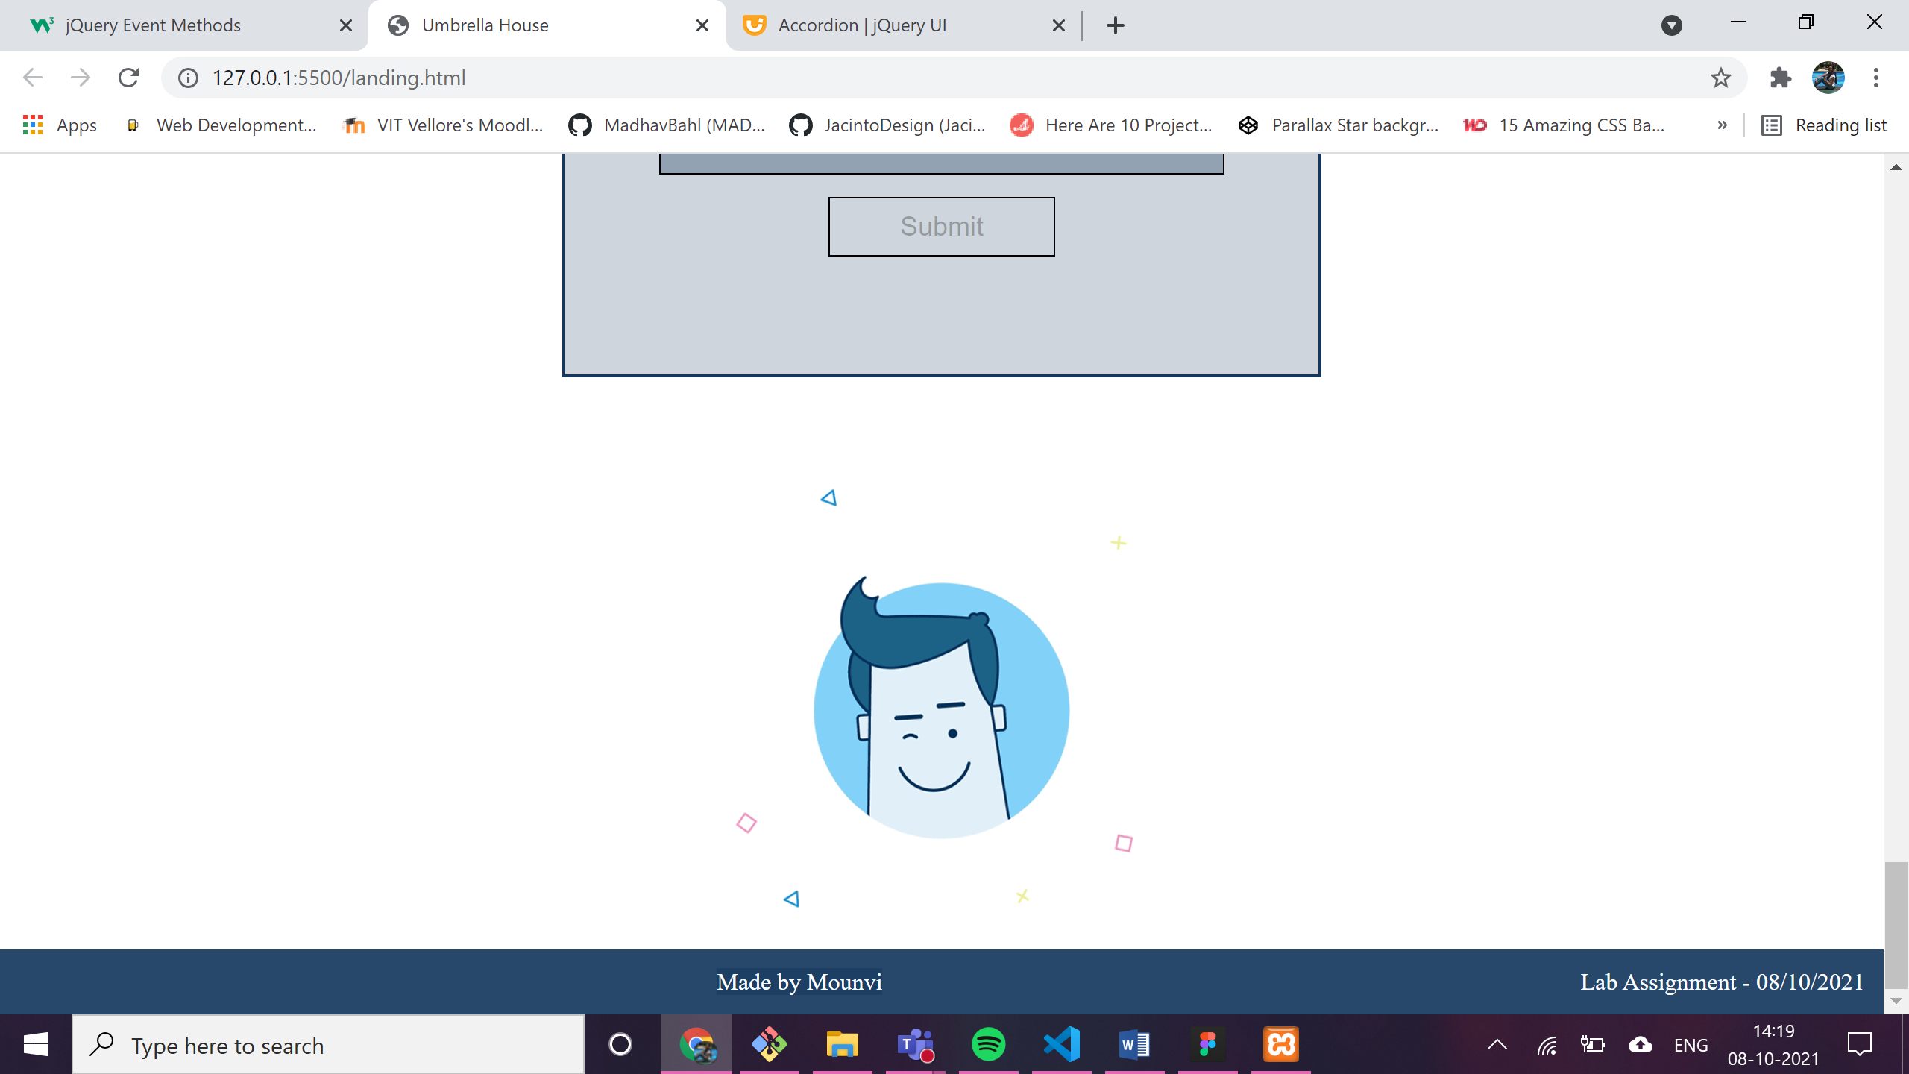

Explored the following in the above assignment:-

* Effects:
  + hide
  + show
  + toggle
  + fade – FadeIn
  + animate
  + stop
  + callbacks
* Events:
  + click
  + dblclick
  + mouseenter
  + mouseleave
  + hover
  + focus
  + blur
  + submit
  + slideDown
  + slideUp
* Others:
  + on
  + attr
  + val
  + text
  + addClass
  + css
  + filter
* interactions and widgets:
  + draggable
  + droppable
  + selectable
  + accordian